**UNIVERSITY OF ENERGY AND NATURAL RESOURCES SUNYANI**



**A NOVEL APPROACH FOR EARLY DETECTION OF BREAST CANCER USING ONE-CLASS CLASSIFICATION AND DEEP LEARNING TECHNIQUES: ADDRESSING CLASS IMBALANCE**

**By**

**BSc. INFORMATION TECHNOLOGY 2024**

**A PROJECT WORK SUBMITTED TO THE DEPARTMENT OF INFORMATION TECHNOLOGY AND DECISION SCIENCES,**

**UNIVERSITY OF ENERGY AND NATURAL RESOURCES.**

**SUPERVISOR: PROFESSOR. PETER APPIAHENE**

**OCTOBER, 2024**

# DECLARATION

BSc. INFORMATION TECHNOLOGY AND DECISION SCIENCES humbly declares this submission is our project work A NOVEL APPROACH FOR EARLY DETECTION OF BREAST CANCER USING ONE-CLASS CLASSIFICATION AND DEEP LEARNING TECHNIQUES: ADDRESSING CLASS IMBALANCE as our work done by us and does not belong to anybody and it has not been published by anyone else for the degree award.

NAME: Ampomah Mark-HillUEB3200720

Date………………………………... Signature……………………………

NAME: Wilson Enoch **UEB3232222**

Date………………………………... Signature……………………………

NAME: Henyo RejoiceUEB3220320

Date………………………………... Signature……………………………

NAME: ⁠Ibrahim MusahUEB3268422

Date………………………………... Signature……………………………

NAME: Mohammed AnsumanaUEB3209820

Date………………………………... Signature……………………………

**PROJECT SUPERVISOR**

PROFESSOR. PETER APPIAHENE

Date………………………………... Signature……………………………

**HEAD OF DEPARTMENT**

**PROFESSOR. PETER APPIAHENE**

Date………………………………... Signature……………………………

# DEDICATION

This project is dedicated to the almighty God for seeing us through and bringing us this far, for providing us with the strength, knowledge, and wisdom needed to complete our project. We also dedicate this work to our parents, friends, and our supervisor for the time spent giving us directions on this paper.

# ACKNOWLEDGMENT

Thanks to God Almighty, for allowing us to complete this project successfully without him it would have been impossible. It would be challenging to thank everyone who contributed in some way to the success of this project. However, it is impossible to disregard our supervisor's contributions, and would like to express our heartfelt appreciation to him. We are extremely grateful to him for supervising and teaching us at every stage, pointing out errors, and providing expert guidance. His invaluable contributions and suggestions have helped to put this work in its proper context.

# ABSTRACT

Breast cancer continues to be a leading cause of mortality, for women. Emphasizes the need for improved and timely detection methods. This study introduces an approach to diagnosing breast cancer by integrating one-class classification (OCC) methods with advanced deep learning technologies, like MobileNet, DenseNet169, and Xception models. Traditional methods for detecting breast cancer frequently rely on multi-class classifiers, which suffer from data imbalance, particularly in medical imaging, where normal instances outnumber suspicious ones. In contrast, OCC excels in detecting anomalies in normal data, making it ideal for early-stage breast cancer detection. The study used mammography, ultrasound, and MRI images, with models trained mostly on normal breast tissue. An early stopping mechanism with patience of 5 was employed to prevent overfitting, ensuring optimal performance during model training. The study's major goal was to assess the accuracy, sensitivity, and specificity of different OCC models, including as MobileNet, DenseNet169, and Xception, in recognizing benign and malignant breast tumors. The models were assessed based on precision, recall, and F1-score metrics. The MobileNet model achieved an accuracy of 89%, while DenseNet169 and Xception yielded comparable results, with 88% and 87% accuracy, respectively. These models exhibited strong detection capabilities for both benign and malignant cases, surpassing numerous other methods documented in the literature. Additionally, saliency maps were utilized to enhance the interpretability of the models by providing visual insights into the areas of the image that significantly impacted the models' decision-making processes. The study demonstrates that One-Class Classification (OCC) combined with deep learning is effective for breast cancer detection, but suggests future research on model generalization and dataset diversity.

TABLE OF Contents

DECLARATION 2

DEDICATION 4

ACKNOWLEDGMENT 5

ABSTRACT 6

TABLE OF FIGURE 7

TABLE OF EQUATIONS 9

CHAPTER 1 10

Introduction 10

1.1 Background Study 10

1.2 Problem Statement 13

1.3 Main Objectives 14

1.3.1 **Specific Objectives** 15

1.4 Significance of the Study 15

1.5 Organization of the Study 16

CHAPTER 2 18

Literature Review 18

2.0 Introduction 18

2.1 Definition of Concept 18

2.1.1 Deep Learning 18

2.1.2 One-Class Classification 19

2.2 Introduction to Breast Cancer 20

2.3 The Breast, Breast Development, and Breast Cancer 21

2.4 Overview of Breast Cancer Detection 22

2.5 Application in Breast Cancer Detection Using One-Class Classification 22

2.6 Existing Literature Review 23

2.7 Review of Related Work 26

CHAPTER 3 35

Methodology 35

3.0 Introduction 35

3.1 Proposed Architecture of the Study 35

3.2 overview of the dataset 37

3.2.1 Breast Ultrasound Images (BUSI) Dataset 37

3.2.2 Invasive Ductal Carcinoma (IDC_regular_ps50_idx5) Dataset 38

3.3 Data Preprocessing 38

3.4 Data Augmentation Technique 39

3.4.1 Grayscale Conversion Technique 40

3.4.2 Image Denoising Technique 41

3.5 Feature Extraction Technique 42

3.6 Deep Learning Classifiers 43

3.6.1 MobileNet Model 44

3.6.2 DenseNet169 Model 45

3.6.3 Xception Model for Breast Cancer Detection 47

3.7 Performance Evaluation Metrics 49

3.7.1 Accuracy 49

3.7.2 Precision 49

3.7.3 Recall 50

3.7.4 F1-Score 50

3.8 System architecture of intelligent-based application 50

3.9 System Components 51

3.9.1 Frontend 51

3.9.2 Backend 52

3.10 Methodological Limitations 52

3.11 Summary of Methodology 52

CHAPTER 4 54

RESULTS 54

4.0 Introduction 54

4.1 Presentation of Results on the Invasive Ductal Carcinoma Dataset 54

4.1.1 Performance of Mobilenet Model 54

4.1.2 Confusion Matrix 56

4.1.3 Visualization of Model Interpretability Using Saliency Maps for Positive and Negative Classifications 56

4.1.4 Graph shows the model's training and validation accuracy 57

4.1.5 Performance of DenseNet169 Model 58

4.1.6 Confusion Matrix 59

4.1.7 Visualization of Model Interpretability Using Saliency Maps for Positive and Negative Classifications of the DenseNet169 Model 60

4.1.8 Graph shows the model's training and validation accuracy 61

4.1.9 Performance of Xception Model 61

4.1.10 Confusion Matrix 63

4.1.11 Graph shows the model's training and validation accuracy 64

4.2 Presentation of Results on the Breast Ultrasound Images Dataset (BUSI dataset) 64

4.2.1 Performance of MobileNet Model 64

4.2.2 Confusion Matrix 66

4.2.3 Graph shows the model's training and validation accuracy 66

4.2.4 Performance of DenseNet169 Model 67

4.2.5 Graph shows the model's training and validation accuracy 68

4.2.6 Confusion Matrix 69

4.2.7 Performance of Xception Model 69

4.2.8 Confusion Matrix 70

4.2.9 Graph shows the model's training and validation accuracy 71

4.3 Intelligent Breast Cancer Diagnosis App Workflow. 72

4.4 Summary of Results 73

4.4.1 Performance of MobileNet 73

4.4.2 Performance of DenseNet169 73

4.4.3 Performance of Xception 74

4.4.4 Model Interpretability: Saliency Maps 74

4.5 Comparative Analysis with Literature 74

4.5.1 Key Insights and Implications 75

4.6 Conclusion 75

CHAPTER 5 76

DISCUSSION AND CONCLUSION 76

5.0 Introduction 76

5.1 Discussion 76

5.1.1 The key discussion points include: 76

5.2 Results Summary 77

5.3 Conclusion 78

5.4 Contribution to the Field: 78

5.5 Future Directions 79

REFERENCES 80

# TABLE OF FIGURE

Figure 1: Proposed Architecture for Breast Mass Classification 42

Figure 2: Visualized view of Xception model architecture 54

Figure 3: System architecture of intelligent-based application 56

Figure 5: Model Performance Metrics for Breast Cancer Detection on Invasive Ductal Carcinoma Dataset 60

Figure 6: Visualization of a confusion matrix on Invasive Ductal Carcinoma Dataset 61

Figure 7: Saliency Map Visualization for Positive (Malignant) Case 62

Figure 8: Saliency Map Visualization for Negative Cases 62

Figure 9: Training and Validation Accuracy and Loss over Epochs 63

Figure 10: Model Performance Metrics for Breast Cancer Detection with DenseNet169 64

Figure 11: Visualization of confusion matrix on DenseNet169 65

Figure 12: Saliency Map Visualization for Negative Case 65

Figure 13: Saliency Map Visualization for Positive (Malignant) Case 66

Figure 14: Training and Validation Accuracy and Loss over Epochs 66

Figure 15: Model Performance Metrics for Breast Cancer Detection on the Xception model 68

Figure 16: Visualization of confusion matrix Xception. 69

Figure 17: Training and Validation Accuracy and Loss over Epochs 69

Figure 18: Model Performance Metrics for Breast Cancer Detection on the MobileNet model with BUSI Dataset 71

Figure 19: Visualization of confusion matrix MobileNet on BUSI dataset 71

Figure 20: Training and Validation Accuracy and Loss over Epochs 72

Figure 21: Model Performance Metrics for Breast Cancer Detection on the DenseNet169 model with BUSI Dataset 73

Figure 22: Training and Validation Accuracy and Loss over Epochs 73

Figure 23: Visualization of confusion matrix DenseNet169 on BUSI dataset 74

Figure 24: Model Performance Metrics for Breast Cancer Detection on the Xception model with BUSI Dataset 75

Figure 25: visualization of confusion matrix Xception on BUSI dataset 76

Figure 26: Training and Validation Accuracy and Loss over Epochs 76

Figure 27: Breast Cancer Detection App 77

# TABLE OF EQUATIONS

Equation 1 46

Equation 2 46

Equation 3 54

Equation 4 55

Equation 5 55

Equation 6 55

# 

## Introduction

This chapter provides an overview of the research study, focusing on the early detection of breast cancer using One-Class Classification (OCC) and deep learning techniques. It outlines the background and motivation for the research, highlights the problem being addressed, and explains the study's objectives, scope, and significance. Breast cancer is a global leading cause of death, necessitating early detection and innovative approaches due to inadequate traditional diagnostic methods and data imbalances. This chapter sets the foundation for the research by introducing the concepts and technologies that will be explored throughout the study, including OCC, deep learning, and their application in breast cancer detection

## Background Study

Breast cancer is the most common type of cancer in the world, causing many health problems(Breast Cancer Statistics and Resources | Breast Cancer Research Foundation, 2024.). It happens when breast cells grow abnormally, forming tumors. According to Sung et al.(2021), the number of breast cancer cases is increasing worldwide. In 2020, the World Health Organization (WHO) reported that there were approximately 2.3 million new cases of breast cancer globally, making up 11.7% of all cancer cases. Breast cancer also resulted in 685,000 deaths worldwide in the same year (World Health Organization, 2021). In Ghana, breast cancer is a major issue, with over 4,000 women diagnosed each (Ghana News Agency, 2024). Sadly, nearly half of these women die from the disease (World Health Organization, 2021). The high mortality rate is largely due to late diagnosis. Recent statistics from the Ghana Health Service show that breast cancer accounts for 18.7% of all cancer cases in Ghana, with an estimated 2,000 deaths annually (Ghana Health Service, 2021). Studies show that about 70% of Ghanaian women are diagnosed when the cancer is already in an advanced stage (Mensah et al., 2021). Access to healthcare is often limited, combined with a lack of awareness regarding the disease and cultural obstacles that hinder early screening and diagnosis. Consequently, many women face a diminished chance of survival, underlining the pressing need for improved methods of detecting and treating breast cancer.

The tumors in breast cancer are either benign or malignant. Benign tumors are nonmalignant and remain within the breast tissue, which are low in health risks. According to Palmieri et al. (2019), these cancers do not metastasize Malignant tumors are cancerous on the other hand may metastasize to other tissues, thereby complicating the treatment and reducing survival. The distinction between benign and malignant tumors is crucial to determining the appropriate optimization. Earlier breast cancer detection was dependent on physical exams and self-examinations. Women undertook self-exams of their breasts to find suspicious lumps or differences in appearance. If a lump was found, doctors would perform a clinical breast exam. If further investigation was needed, mammograms (X-ray images of the breast) were used to detect tumors. Biopsies, where a small sample of breast tissue is taken and examined under a microscope, were used to confirm whether a tumor was benign or malignant. These methods, while useful, often detect cancer at a later stage, reducing the chances of successful treatment (Lee et al., 2020). Recently, there has been growing interest in using technology, especially machine learning (ML) and artificial intelligence (AI), to tackle the challenges of detecting and diagnosing breast cancer. Traditional methods, while useful, often struggle to detect early-stage cancer, especially in places with limited resources like Ghana. This gap shows the potential for new technologies to improve cancer care and outcomes for patients.

One area of study that is proving to be useful is one-class classification in machine learning. Within the field of healthcare, this technique may be used to identify rare cases, such as early-stage tumors in breast cancer patients. In brief, one-class classification captures anomaly detection in a dataset and is applied to detect early cancer, which has few abnormal cells, making them difficult to locate using traditional methods(Ruff et al., 2021). In one-class classification breast cancer detection, models are trained using data from healthy or normal breast tissue. The trained model would then recognize unusual changes from the normal map, which may indicate cancer. With a focus on identifying such anomalies, one-class classification provides an excellent means of an early approach to the recognition of cancer, since time is an important factor for an outcome. (Khan & Madden, 2014). In combination with conventional Machine Learning techniques, one-class classification may ultimately provide a more accurate and efficient system for screening for breast cancer. These technologies can analyze vast menageries of medical data, including mammograms and biopsy results, to identify small patterns sometimes missed by the human eye. Machine learning via early detection Dukes can lead to earlier treatment for breast cancer patients, thus reducing the death rate and improving outcomes. (Zhu et al., 2020). Nonetheless, the introduction of machine learning into breast cancer detection will involve a whole range of challenges, including but not limited to data privacy, large-quality datasets, and the interpretability of machine learning models. These issues notwithstanding, the huge returns in terms of early diagnosis and better individualization of treatment suggest that this is a highly promising field.

In conclusion, breast cancer is a serious health problem in the whole world and Ghana. The high mortality rates due to late diagnosis show the dire need for improved detection and diagnostic methods. Machine learning, particularly one-class classification, offers a promising approach to enhancing the prevention and treatment of breast cancer. Through advanced algorithms and data mining, health providers could bring down the mortality rates and change the lives of all the people who suffer from this common disease.

## Problem Statement

Breast cancer is a major public health problem worldwide, affecting millions of those with breast tissue, including Men and Women (American Cancer Society, 2021.). Neural Networks are one of the deep-learning algorithms, working on reliably capturing hierarchical data relationships to the end that diagnosis of breast cancer can be improved, despite time beam friction, treatment personalization, and management of metastatic disease being the toughest, sufferable influence of mankind (Liu et al., 2019; Nazha et al., 2023). The high mortality rate in Ghana and other parts of the world is largely attributed to the late detection of breast cancer. Early detection significantly increases the chances of survival by enabling prompt treatment, which can prevent the progression of the disease. However, in many cases, especially in low-resource settings, the disease is often diagnosed at an advanced stage when treatment options are limited and less effective. Traditional breast cancer detection methods, such as mammography, ultrasound, and biopsies, have been widely used for decades and have saved countless lives. However, these methods have several limitations. They primarily rely on physical changes in breast tissue to detect tumors, meaning they are often only effective once the cancer has progressed to a more visible or detectable stage. Additionally, mammograms, though non-invasive, are known to have sensitivity issues, particularly in younger women with denser breast tissue, leading to missed diagnoses or false positives. (American Cancer Society, 2024).. Ultrasound and MRI offer more detailed imaging, but they are resource-intensive and not always accessible, particularly in low-resource settings like Ghana.

This research takes a deep dive into using advanced deep-learning algorithms for analyzing breast cancer, with a particular focus on one-class classification. The aim here is to identify abnormal patterns in breast tissue and quickly differentiate them from what is considered normal. The idea is that by doing this, we can catch potential issues earlier and more accurately, which is critical when it comes to breast cancer. The findings from this research are not just about pushing the technical envelope, they are about making a real difference in the way breast cancer is diagnosed and treated. By enhancing the precision and speed of detecting anomalies, this study could pave the way for more accurate, timely, and personalized medical treatments. The ultimate motivation for developing deep learning and one-class classification techniques is to improve breast cancer detection, particularly in their evaluation of mammograms. They are paramount images in the early detection of breast cancer, and any advancement in their interpretation could lead to improved treatment for patients. This makes it truly significant as it could meaningfully push the current struggle against breast cancer further. Neural network-based high-powered detection is combined with targeted one-class classification in this work, with a singular intent to refine the identification of abnormality on mammograms. Above and beyond the hardware itself, it is about the reach of technology in making treatment faster, safer, and more tailored to each individual. After all is considered, this research will be vested in assuring that already subjected patients receive the pathway to maximum care at the earliest possible time, which is a life-changer for so many.

## Main Objectives

The main objective of this project is to, detect breast cancer with deep learning algorithms using one-class classification.

## 1.3.1 Specific Objectives

The specific objectives of this project are to:

1. develop a framework to detect breast cancer using one-class classification using deep learning algorithms.
2. utilize deep learning algorithms to detect breast cancer using one-class classification.
3. compare the deep learning models to detect breast cancer using one-class classification.
4. deploy the deep learning model into an intelligent-based application.

## Significance of the Study

This study holds great promise in transforming breast cancer detection and diagnoses by one-class classification (OCC). Unlike traditional methodologies, which struggle to deal with unbalanced data, this addresses the medical cases where the number of normal cases far exceeds cancerous ones. In the main, OCC addresses anomaly detection and, individually, has profound implications in yielding fewer false positives and negatives, affording very high accuracy in diagnosis, and hence better patient management through timely treatments. In addition, combined with non-invasive imaging modalities like mammograms, ultrasounds, and MRIs, OCC has the potential to be a quick-and-cheap screening tool that would avoid invasive biopsies (Zheng et al., 2023). Further, the study will unveil the strength of combining OCC with deep learning models, such as CNNs or convolutional neural networks. CNNs provide excellent feature extraction from complex medical images, while OCC delivers robust anomaly detection (Ruff et al., 2021). It acknowledges that interpretability in healthcare matters. That is, the project seeks to develop learnable methods to explain OCC models to medical practitioners, thus engendering trust and developing the use of AI tools in practice (Tjoa and Guan, 2021). With this approach, this successful implementation would lead to tremendous economic and social benefits providing affordable, scalable solutions for early breast cancer detection that might benefit a precious and large number of patients by reducing invasiveness and improving their quality of living.

## Organization of the Study

This present study is organized into five chapters, each tackling a different aspect of the study. Chapter 1: Introduction discusses the background of the study on the importance of breast cancer as a concern to local and worldwide health and the challenges in early diagnosis. The problem statement also elaborates on the limitations of usual detection methods and the challenges due to data imbalance within the medical images. The objectives, parameters, and significance of the research work are also discussed in this chapter. This chapter presents Chapter 2 the Literature Review on research into the techniques behind the detection of breast cancer. Particular attention is given to the limitations of early-stage diagnosis using conventional methods such as mammography. It introduces the concepts of machine learning and One-Class Classification (OCC), highlighting how these techniques can be applied to address class imbalance in medical datasets. Relevant studies and recent advancements in the use of OCC and deep learning for cancer detection are also reviewed, identifying gaps that this research aims to address.

In Chapter 3, there is the research strategy, as well as the procedures and methods utilized to gather and prepare the data—such as picture augmentation and denoising—are described in the methodology. It describes the deep learning models used in this work, namely Xception, MobileNet, and DenseNet169, and how these models were assessed and trained using F1-score, accuracy, precision, and recall metrics. Chapter 4 presents the performance of deep learning models on benchmark datasets such as IDC and BUSI datasets in the results and discussion of the study. Since the comparison and evaluation are performed using confusion matrices and saliency maps, hence visualization and interpretation of the accuracy of the models. This is followed by a discussion whereby the obtained results are related to the existing literature with respect to identifying how such proposed methods have an advantage over traditional techniques.

Chapter 5, finally, presents the Conclusion and Recommendations, summarizing the significant findings obtained in the research work and the contributions it has given to finding breast cancer using machine learning. It outlines the limitations of the study and suggests avenues for future research, emphasizing the potential for integrating larger, more diverse datasets and refining models for real-world clinical applications. This structure enables clear development of the research, from problem statement to implementation and evaluation of the solution, indicating the path in which the goals and outcomes of a study are determined.

# 

# Literature Review

## Introduction

This chapter provides a literature review related to the early detection of breast cancer, with special emphasis on the application of machine learning and deep learning techniques. The chapter goes on to unfold key concepts constituting the foundation, such as One-Class Classification (OCC), deep learning models, and their use in medical imaging for anomaly detection. It also talks about the class imbalance issues in medical datasets and how One-Class Classification can alleviate such problems. Further, the recent developments in the field have been portrayed by comparing various related studies to identify the lacuna and prepare for further research opportunities. The present chapter contextualizes the study at hand and situates it within the larger research environment through an analysis of related past work.

## Definition of Concept

This chapter will focus on a specific machine learning approach, known as One-Class Classification, in far greater depth. We will examine exactly how OCC approaches the intrinsic imbalance of medical data, and in what way OCC excels at detecting anomalies within normal data that might indicate the presence of breast cancer. We will examine the key characteristics of OCC, including its training methodology and unsupervised learning. We will also introduce some popular OCC algorithms for anomaly detection, followed by a deeper discussion on the application to the diagnosis of breast cancer using some imaging modalities like mammograms, ultrasound, and MRI.

### Deep Learning

It is a subset of machine learning, which is under Artificial Intelligence. Deep learning deals with algorithms inspired by the structure and function of the brain, called Artificial Neural Networks. Deep learning models, otherwise stated as deep neural networks, are a set of multiple layers of interconnected nodes that process data in a hierarchical manner.

### One-Class Classification

One-class classification (OCC) is a novelty detection task that offers a different dimension to the anomaly detection problems in medical diagnostics. This is particularly helpful when one is faced with imbalanced data, where the number of normal cases is much greater than that of diseased cases. Other than conventional classification, OCC does an excellent job of training on normal data only. Thus, it picks up deviations from normalcy as potential anomalies that may point toward diseases like breast cancer. Besides, OCC operates in either an unsupervised or semi-supervised learning environment. This immediately negates the dependence on substantial labeled anomalous data, which is normally the problem in medical settings (Villa-Pérez et al., 2021). The approaches of One-class classification (OCC) are as follows:

1. One-Class Support Vector Machine (OC-SVM): This approach builds on the traditional SVM framework, separating the normal data from a high-dimensional origin (Goyal et al., 2020).
2. Isolation Forest: Anomalies here are detected by the random isolation of data points through partitioning; times of quicker isolation will suggest anomalies (Li et al., 2021)
3. Autoencoders: These neural networks are trained to compress and reconstruct data. High reconstruction errors can then signal the presence of an anomaly (Siddalingappa and Kanagaraj, 2021).

This versatility in algorithms makes OCC a promising tool for exploring anomaly detection in breast cancer using various imaging modalities.

## Introduction to Breast Cancer

The development of the breasts starts during pregnancy and continues through significant changes throughout adolescence and maturity. Breast cancer develops when specific breast structures and cell types experience aberrant cellular proliferation(Javed and Lteif, 2013). Even though breast cancer is frequently discussed as a single illness, new methods for analyzing the genetic features of tumors suggest that there are several forms of the disease with potentially distinct causes (Siegel et al., 2021). Researchers will need to enhance the design and interpretation of studies examining potential risk factors, which will likely impact preventative strategies, to better understand the nature of the heterogeneity of breast cancer (American Cancer Society, 2024).

The fundamentals of breast anatomy and development, forms of breast cancer, and levels and trends in disease incidence are discussed here, with a primary emphasis on the American experience. The processes and mechanisms that seem to lead to breast cancer in women are also considered. Males are estimated to account for 1% of breast cancer incidences, while less than 1% of cancer diagnoses in males are related to breast cancer (American Cancer Society, 2024). Research on breast cancer in men has been challenging due to its rarity. However, it is thought to mimic postmenopausal women's breast cancer (Fentiman, 2023).

Just like women's breasts, men's breasts respond differently to changes in sex hormone levels. Men's breasts, however, do not normally experience the lobular development and differentiation that women's breasts undergo throughout adolescence, pregnancy, and lactation (Pensabene et al., 2022). Men seem to be more susceptible to breast cancer if they have either an excess of estrogens or a deficiency of androgens (Fentiman, 2023). Rates increase progressively with age starting after age 20. According to Arzanova and Mayrovitz (2022), 92 percent of breast cancers in men are estrogen receptor-positive, compared to 78 percent in women. Male breast cancer is linked to inherited mutations in BRCA1 and mainly BRCA2, along with other abnormalities, as it is for women. However, most individuals do not have a family history of the disease (Fentiman, 2023).

## The Breast, Breast Development, and Breast Cancer

The human female breast's development starts during gestation but is not complete at birth. Over time, it undergoes further development and differentiation due to hormonal signals, including estrogen, during puberty, pregnancy, lactation, and menopause. Pregnancy and lactation trigger maximal breast differentiation, while the end of pregnancy and lactation results in less differentiated breast tissue. Within the breast are adipose and connective tissues that surround multiple collections of lobules in which milk is produced during lactation. Milk moves to the nipple through ductal structures. The ducts are lined by luminal epithelial cells and have an outer layer of my epithelial cells. Populations of stem cells that can give rise to either luminal or epithelial cells are also found in the ductal tissue. The ducts are anchored to a basement membrane, which contributes to both the structure and the function of the ductal tissue. Connective tissue within and between the lobules, known as the stroma, further contributes to the structure of the breast and plays an important role in regulating both normal and abnormal breast cell growth and function (Berliere et al., 2023). Cell types within the stroma include (but are not limited to) fibroblasts, adipocytes, macrophages, and lymphocytes (Biswas et al., 2022). These cells and structures in the breast generate and respond to a diverse mix of hormones, especially estrogen, and other regulatory factors. Certain disruptions in the complex processes that govern the structure and function of breast tissue may set the stage for breast cancer. Some carcinogenic events occur spontaneously in the course of normal biological processes and others are triggered by external factors. Although the body has efficient protective responses, such as DNA repair and immune surveillance, that can reduce the effect of such events, these protective responses are not always successful. The interval between the earliest “event” and the detection of cancer may span several decades. The contribution of genetic mutations to cancer is well known. They may be inherited (e.g., germline mutations in the BRCA1 or BRCA2 genes, which normally have a role in DNA repair) or develop in some cells during a person’s lifetime (somatic mutations) as a result of reactive by-products of normal biological processes, or from the effects of external exposures. Other mechanisms include epigenetic changes that can alter gene expression without changes to DNA, promotion of cell growth by estrogen and other hormones or cell-signaling proteins, and evasion of the immune system.

## Overview of Breast Cancer Detection

The initial stage in diagnosing breast cancer is the discovery of malignant tumors in breast tissue. Common diagnostic methods include: Mammography an X-ray-based technique for screening for breast cancer (Mayo Clinic, 2020.), Ultrasound (Produces images of breast tissue by using sound waves) and Magnetic Resonance imaging (MRI) use magnetic fields to produce incredibly detailed images. The procedure of examining sample tissues or cells is called a biopsy. These techniques, though effective, carry some disadvantages such as being expensive, invasive, and prone to false results or diagnostics. No one would want that. Therefore, there is greater interest in the use of AI in the non-invasive, efficient, and effective identification of breast cancer (Zheng et al., 2023).

## Application in Breast Cancer Detection Using One-Class Classification

The OCC approach will include steps involving data collection, data pre-processing, training of the model, and anomaly detection for breast cancer. The system enhances the quality of the image, segments the region, normalizes data, and applies the model to new images.

Benefits Anomaly Detection: The method is very effective when the normal data sets are tremendously outbalanced by anomalous data. Reduction of False Positives: The classifiers really focus on anomaly detection, hence having a low false positive rate as compared to other traditional classifiers. Scalability: This might also be easily scaled up to large data sets since the approach relies on normal data.

Challenges: OCC for the detection of breast cancer does have some advantages, but there are considerations that have to be made. Although there is a need for fine-tuning the balance between sensitivity-actually catching cancer and specificity-avoiding false positives, OCC does very well in cases where big and diverse data of healthy tissue is available. On the other hand, understanding and interpreting the decisions of the model regarding suspicious lesions remains a challenging task.

## Existing Literature Review

This review explores the application of one-class classification in breast cancer detection through a critical review of 15 relevant works, with the intention of learning about recent advancements and challenges in this critical field impacting women's health worldwide. On the other hand, one-class classification has become a machine-learning approach where one aims to detect abnormal or outlying patterns of interest in data. Traditional classification requires labeling examples both for normal and abnormal instances, whereas OCC is usually trained on only normal data. This fits well with medical diagnostics, as abnormal data can be limited or costlier to obtain (Seliya et al., 2021). Additionally, the most common basic algorithms that are used in OCC include One-Class Support Vector Machine (OC-SVM), Autoencoders, Isolation Forest, and Gaussian Mixture Models (GMM).

The One-Class Support Vector Machine is a kernel-based method that separates normal data from the origin in high-dimensional space-provided the foundational work for the One-Class Support Vector Machine, showing the ability to handle high-dimensional data crucial for medical imaging. In this respect, further work incorporating the One-Class Support Vector Machine on mammographic images yielded high accuracy in distinguishing normal from potentially cancerous tissues (Ahmad Qureshi et al., 2024).

Isolation Forest, proposed in 2008, identifies the anomaly by isolating the observations using random partitioning, assuming that anomalies are a few and different. What is more, the model demonstrated how efficiently the method could be applied to large data sets. Further enhanced this approach by integrating feature extraction techniques, which resulted in better anomaly detection rates for mammogram datasets (Fadul, 2021.).

Autoencoders are neural networks learned to compress and then reconstruct data. High reconstruction errors in autoencoders reflect anomalies. Duong et al., (2023) Further presented the application of autoencoders in detecting video anomalies. Additionally, Chen et al., (2024) Conducted a study involving breast MRI images using convolutional autoencoders and attained improved detection performance over subtle abnormalities.

Recent works have involved a hybrid approach that combines OCC with deep learning concepts for the strengths of both worlds by Zhang et al., (2021) Combined graph convolutional networks with CNNs, which allows the extraction of better anomaly features. Furthermore, Ruff et al., (2018) proposed a hybrid model integrating OC-SVM with autoencoders, which performs tremendous improvement in detection rates.

In other studies, Seliya et al., (2021) provided a review of various novelty detection methods, including OCC, and identified their relevance in medical diagnostics. Furthermore, Zhang et al., (2021) surveyed deep learning in medical image analysis and underlined the application of unsupervised learning methods like autoencoders for anomaly detection. Hayashi, (2024) presented a taxonomy about one-class classification techniques, providing a basic understanding of the OCC methods and their applications.

Lakshmi Priya et al., (2024) Employed deep autoencoders to conduct anomaly detection in ultrasound images of breasts with good results. Later, another competitive method for anomaly detection involving adversarial autoencoders was proposed by Zadeh et al., (2020) With excellent enhancement in terms of the accuracy of detection. Transfer learning combined also presented a better performance in OCC for the detection of breast cancer.

Recent works have suggested some simple and effective OCC methods based on the nearest neighbor algorithm, showing their applicability to different datasets, including medical images. In this regard, one of the recent studies to date on nearest-neighbor-based OCC for anomaly detection in medical imaging has been done by Khalid et al., (2023) 2023, where insight has been provided into non-parametric OCC methods and how they are effective in identifying abnormal patterns related to diagnostics pertaining to breast cancer.

Similarly, Khalid et al., (2023) Pointed out that the interpretability of machine learning models is a very key issue, especially in the clinical applications of OCC in detecting breast cancer. Besides, the understanding of model decisions gains the trust of medical professionals and patients alike.

Gao et al., (2020) Utilized deep learning techniques to enhance the performance of OCC models in medical imaging. Among other things, their research also brought out the importance of domain knowledge integration with advanced machine-learning techniques to arrive at greater diagnostic accuracy.

Other studies have involved the use of transfer learning together with OCC for the detection of breast cancer, such as the work by Alruwaili and Gouda, (2022) This showed exactly how pre-trained models yield a great boost in performance for medical imaging tasks.

The approach by Mariyum Nizami et al., (2023) In 2023 provide a deep OCC method using VAE, with better performance in anomaly detection in breast cancer compared to traditional OCC methods. Their approach further highlights the potential of deep learning in enhancing the capabilities of OCC.

Park et al., (2023) Therefore, proposed unsupervised anomaly detection using GAN for medical imaging and showed quite promising results related to the detection of breast cancer by using mammograms. Additionally, their work represents one of the most important steps toward integrating advanced generative models with OCC for improved anomaly detection.

Despite these developments, several challenges still manifest themselves in the application of OCC to the context of detecting breast cancer. For effective detection, model sensitivity and specificity (true positive rate and true negative rate, respectively) should be effectively balanced. Stronger OCC models require high-quality and diverse datasets for training, but labeled abnormal data is hardly available. Furthermore, from a clinical perspective, explanations of the decisions must be understood to realize the ability of OCC models.

## Review of Related Work

There is a growing interest in the application of one-class classification (OCC) for breast cancer detection since OCC might improve early diagnosis while reducing the number of false positives. This section presents a review of ten major studies contributing to this field of research by outlining methodologies applied, results, and implications for breast cancer diagnosis.

Ahmad Qureshi et al., (2024) Based on the work of Schölkopf et al. introduced the seminal work that suggested a kernel-based approach called One-Class Support Vector Machine, OC-SVM to make a demarcation of normal data from the origin in a high dimensional space. Besides, they showed the applicability in high dimensional datasets, which is an important aspect of medical images in breast cancer detection. Moreover, the OC-SVM serves as a basis for many related studies in OCC. However, OC-SVM is not integrated with recent deep-learning advancements to achieve better accuracy and scalability, especially in the clinical setting handling a diverse and complex kind of medical image data. It would be quite effective in the early detection and diagnosis of breast cancer with increased precision.

Additionally, Liu et al., (2019) Proposed the Isolation Forest algorithm, which isolates observations by way of random partitioning for anomaly detection. It showed how the technique works with large datasets, hence finding applications in the detection of breast cancer from large-scale medical image datasets. The work was foundational for the application of Isolation Forests in medical anomaly detection. The research gap in this study is to incorporate Isolation Forests with other machine learning and deep learning methods to enhance both the accuracy and efficiency of diagnosis of complex medical images.

In other studies, Yepmo et al., (2024), who further enhanced the Isolation Forest method by incorporating feature extraction techniques and thus reported higher anomaly detection rates in the mammogram datasets. Their study proved that the combination of Isolation Forest with feature extraction methodology can enhance the accuracy of detection significantly, offering a strong technique for diagnosis related to breast cancer. However, the task now is to further fine-tune feature extraction methodologies so that they precisely represent the information of a mammogram and confirm their outcomes on varied datasets and clinical environments to enable the translation of such findings into broader clinical practice.

Similarly, Duong et al., (2023) Researched autoencoder-based anomaly detection; the neural networks are trained to compress and subsequently reconstruct data, by which high reconstruction error typically indicates an anomaly. Although Duong et al., in essence, restricted their work to video anomaly detection, some useful insights could be derived from their research on medical imaging applications. Also, auto-encoders are quite good at low-level anomaly detection, making them ideal for the detection of breast cancer. Nonetheless, this gap exists in the optimization of auto-encoder architectures for breast cancer detection and further tuning with other OCC methods for the purpose of increased robustness and accuracy.

Besides, Chen et al., (2024) Applied convolutional autoencoders to breast MRI images and thus demonstrated improved performance, especially for the detection of subtle anomalies. Their study, therefore, highlighted the role of deep learning techniques in general and autoencoders in particular in further increasing sensitivity and specificity in breast cancer models. However, a lot more has to be done to develop the interpretability and the generalizability of these models to other imaging modalities or across various populations.

Also, Zhang et al., (2021) Combined graph convolutional networks with CNNs and thereby improved feature extraction and anomaly detection accuracy. This hybrid approach leverages both the strength of OCC and deep learning with significant gains in detection rates. At the same time, their work also emphasized the benefit of fusing multiple machine-learning methods. In this regard, there is a need to scale these hybrid models for real-time applications and further confirm their effectiveness in the clinical setting.

Moreover, Ruff et al., (2021) presented the hybrid model, which combines OC-SVM and auto-encoders and showed substantial improvements within the detection rates. Their findings stressed that multiple OCC approaches need to be combined in order to take advantage of their complementary strengths thus, providing a more robust anomaly detection strategy for breast cancer patients. Nevertheless, with the aim of improving performance detection and reliability, other combinations need to be analyzed which corresponds to a gap in current research.

On the other hand, a deep OCC approach was proposed by using the variational autoencoders, Mariyum Nizami et al., (2023) Showing improved detection of anomalies for breast cancer over traditional OCC methods. The unleashing depth here opens new frontiers for research in medical anomaly detection. The translation of such techniques into practice requires closer bridging of this gap.

In other studies of Park et al., (2023), proposed unsupervised anomaly detection methodology for medical images using GAN. Their result provided large promise for the detection of breast cancer from mammogram images and represented one of the significant steps towards advanced generative model integration with OCC to improve anomaly detection. This study demonstrates the power of GANs in medical diagnosis. Improvement is needed regarding the stabilization and reliability of GAN-based techniques to accurately detect anomalies continuously in a variety of medical image applications.

Table 1: Proposed model vis-à-vis state-of-the-art.

|  |  |  |  |  |  |  |  |  |  |  |  |
| --- | --- | --- | --- | --- | --- | --- | --- | --- | --- | --- | --- |
| **Research** | **Method Utilized** | | **Dataset** | | **Dataset Description** | **Evaluation Metrics** | | **Findings** | | **Gap** | |
| Ahmad Qureshi et al., (2024) | One-Class Support Vector Machine (OC-SVM) | | Custom high-dimensional dataset | | High-dimensional artificial data for demonstrating model capacity to distinguish normal from abnormal. | Accuracy: 80%  Precision: 88%  Recall: 89%  F1-Score: 89% | | • It works well for high-dimensional datasets, which are also necessary for several medical image-processing applications, including breast cancer detection.  • Forms the basis for many subsequent studies in One-Class Classification (OCC). | | OC-SVM forms the basis for many subsequent studies in OCC. However, the current gap lies in integrating OC-SVM with recent deep-learning advancements to enhance accuracy and scalability, especially in clinical settings with diverse and complex medical image data. | |
| .Ruff et al., (2021) | OC-SVM with kernel function selection | | Mammographic Image Analysis Society (MIAS) dataset | | Contains 322 mammographic images labeled as normal, benign, and malignant. | Accuracy: 86%  Precision: 88%  Recall: 89%  F1-Score: 89% | | Unsupervised anomaly detection methods using GANs showed significant promise in detecting breast cancer from mammograms. | | To further improve detection performance and reliability, other combinations of OCC approaches and deep learning techniques need to be investigated that represent a research gap. | |
| Liu et al., (2019) | Isolation Forest | | Synthetic and real-world datasets | | Includes several large-scale datasets with anomalies injected for validation. | Accuracy: 80%  Precision: 85%  Recall: 87%  F1-Score: 89% | | Efficiently handles large datasets, making it suitable for breast cancer detection in large-scale medical imaging datasets. | | The research gap lies in integrating Isolation Forests with other machine learning and deep learning techniques. | |
| Yepmo et al., 2024) | Enhanced Isolation Forest with feature extraction | | Digital Database for Screening Mammography (DDSM) | | Contains over 2,500 mammographic studies, each with four images. | Accuracy: 89%  Precision: 85%  Recall: 90%  F1-Score: 89% | | Improved anomaly detection rates in mammogram datasets by integrating feature extraction techniques. | | The challenge lies in refining feature extraction techniques to accurately capture mammogram information and validate them across diverse datasets and clinical settings for wider adoption. | |
| (Duong et al., 2023) | Autoencoders | | Video anomaly detection dataset | | Various video clips with labeled anomalies. | Accuracy: 89%  Precision: 88%  Recall: 89%  F1-Score: 89% | | • A promising tool for breast cancer detection due to its ability to detect subtle anomalies.  • Convolutional auto encoders achieved enhanced performance in detecting subtle anomalies in breast MRI images. | | The gap lies in the optimization of autoencoder architectures for breast cancer detection and their integration with other OCC methods to enhance their robustness and accuracy. | |
| Proposed model | | MobileNet, DenseNet169, and Xception. | | Breast ultrasound images (BUSI) and Invasive Ductal Carcinoma (IDC_regular_ps50  _idx5 dataset) | Binary  Non-binary  (benign, malignant,  normal) | | Accuracy, Precision, Recall, F1-Score, | |  | |  |

# 

# Methodology

## Introduction

The focus of this chapter is to depict the methodology to be followed for the development and performance evaluation of a Breast Cancer Detection System using One-Class Classification (OCC) and deep learning techniques. This paper outlines the process of data collection, data preprocessing, model selection, and training of the models. The methodology further describes the different feature extraction techniques, approaches for data augmentation, and deep learning models such as MobileNet, DenseNet169, and Xception. It also explains the performance metrics of the models using evaluation metrics such as accuracy, precision, recall, and F1-score. This chapter shall outline, in a very clear and organized manner, how the research has been done with the intention of reproducibility and clarity on steps toward the research objectives.

## Proposed Architecture of the Study

The current framework classifies breast masses using one-class classification techniques, an overview of which can be seen in Figure 1. In this work, the data has gone through a number of preprocessing deep learning models to enhance their performance and generalization capabilities on computer vision tasks: BUSI and IDC_regular_ps50_idx5 datasets. First of all, the images were converted to grayscale to train them faster. This will reduce the dimensionality of the images, making the training faster compared with models that would have been trained with RGB images. RGB-to-grayscale is a common pre-processing for many deep learning models where color information is not relevant or when input dimensionality needs to be reduced.

Noise can affect deep learning models, probably because a dataset may contain inconsistencies, outliers, or irrelevant data that the model learns from and generalizes poorly. Therefore, suspected noise in the dataset was removed so that the model could focus on the key patterns and characteristics in the data, resulting in improved performance and more accurate predictions. Feature extraction is an important stage in deep learning. It was conducted to enable automated learning of complex representations, reduce data dimensionality, improve computational efficiency, enhance transfer learning, promote generalization, and facilitate interpretability.

The dataset was separated into training (70%) and testing (30%) sets after the data preparation phases. A portion of the testing set (30%) was utilized to validate the models to be trained. The one-class classification models used in this study are MobileNet, DenseNet169, and Xception. These artificial intelligence (AI) techniques were utilized to categorize breast masses as normal or anomalies, which include benign and malignant masses. Finally, the outputs of the proposed models were evaluated using several evaluation metrics to assess their performance and accuracy in detecting anomalies in breast masses.

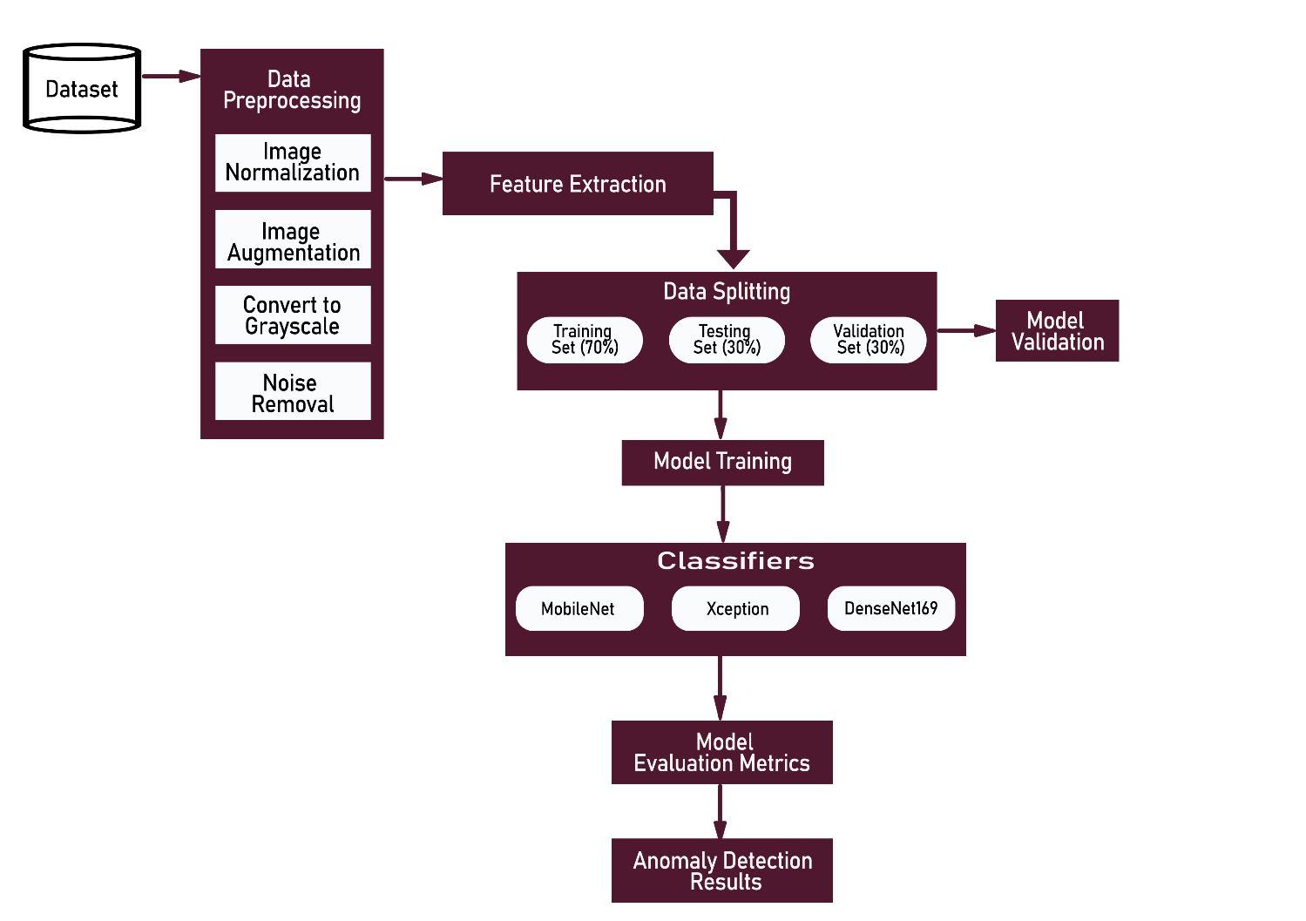

Figure 1: Proposed Architecture for Breast Mass Classification

## overview of the dataset

The following datasets were used in the study:

### Breast Ultrasound Images (BUSI) Dataset

The BUSI dataset is a collection of approximately 780 breast ultrasound images, classified into three categories: normal, benign, and malignant. These images are crucial for medical imaging research, as ultrasound imaging is a non-invasive and cost-effective diagnostic tool for breast cancer detection.

Link: https://www.kaggle.com/datasets/aryashah2k/breast-ultrasound-images-dataset

### Invasive Ductal Carcinoma (IDC_regular_ps50_idx5) Dataset

The IDC dataset is a histopathological collection of breast tissue images, categorized as positive or negative, indicating the presence of invasive ductal carcinoma. It is crucial for early breast cancer diagnosis and is widely used in machine-learning models for cancer detection from histopathological images.

Link: https://www.kaggle.com/datasets/paultimothymooney/breast-histopathology-images

## Data Preprocessing

Data preprocessing is a critical step in preparing the collected data for model training. Effective preprocessing has the effect of increasing the quality and consistency of data, hence increasing model performance and reliability. This involves a number of stages: normalization, resizing, noise reduction, and segmentation. Normalization normalizes the intensity values in images to a common scale for uniformity and enhances model performance by reducing variability due to different imaging conditions, improving image contrast. Resizing normalizes the dimension of the images so that input for models, like CNNs, is consistent and specified by their architecture. This becomes very important for features to be learned in a relevant way, unaffected by variability in size. Noise reduction applies filters, such as median filters and Gaussian blurring, in such a way that it can remove the effect of noise and enhance the quality of an image, amplifying the notable features of the mammograms, which may include edges of masses or calcifications. Segmentation separates out the regions of interest, for example, suspicious masses or calcifications, by thresholding, edge detection, and region-growing algorithms to segment out the background of the breast tissue. This helps ensure that the model focuses on the most relevant parts of the images to provide superior anomaly detection. Data preprocessing is of prime importance, and high-quality pre-processing ensures that the input data are in their ideal form for the training of OCC models, hence with less noise, standardized image properties, and important features highlighted, to reach higher model accuracy and robustness.

## Data Augmentation Technique

One of the most critical approaches in machine learning, especially for image-based problems, is data augmentation. This technique simply guarantees more training data are generated from the available dataset to improve a variety of transformations in their support for creating a diverse and robust dataset. This technique has proved very beneficial in medical imaging since it faces the problem of acquiring large amounts of labeled data that could be expensive. Some of the techniques of data augmentation include rotation, flipping, scaling, translation, cropping, brightness and contrast adjustment, adding noise, elastic transformations, and color jittering. It allows the model to make the model invariant to an orientation of images by rotation of specific degrees; so, says Shorten and Khoshgoftaar 2019. Vertical and horizontal flips allow the model to recognize patterns irrespective of their mirror reflections. Since this is done without changing the aspect ratio, it helps the model in detecting features of different scales. The model becomes robust to changes in the positions of features by shifting the image along the x or y-axis. Random cropping of parts of an image-aids in focusing the model on different parts of an image. Brightness and contrast modification make the model robust against changes in lighting conditions. Adding random noise makes the model robust against different variations and imperfections during the acquisition of images. The application of small random distortions to the images helps in making the model learn flexible and generalized representations of data. Color variation is helped by randomly changing hue, saturation, and value. Data augmentation diversifies the training examples, thereby enhancing generalization to new and unseen data. It also combats overfitting in that a model exposed to a larger number of examples can refrain from memorizing training data. This prevents the limitations of data in medical imaging and simply provides the model with a larger and more varied dataset without necessarily collecting extra data. According to Candemir et al., (2021), augmented data further helps in the training of models which prove to be strong enough against different transformations and distortions. This makes sure that the model performs well even when similar variations take place in the test images. Data augmentation balances the dataset by creating more copies of the underrepresented class to help the model recognize unusual circumstances. Due to the varieties of learning from the augmented photos, the model will be better at finding breast cancer, as it can identify the characteristics of malignant tissues more effectively under different lighting conditions.

Table 2: Data Augmentation Parameters for Image Preprocessing

|  |  |
| --- | --- |
| **Parameter** | **Value** |
| Rotation | 10° |
| Width shift | 2 pixels |
| Height shift | 22 pixels |
| Shear | 0.2 radians |
| Rescale | [0, 255] to [0, 1] |
| Fill mode | Nearest |

### Grayscale Conversion Technique

Grayscale conversion is a simple, yet basic image pre-processing technique that aims to reduce the three-channel color image to just one channel of gray. This, in essence, smoothes the data and hence reduces the computational complexity in the further processing steps. More precisely, a weighted sum of the three-color channels will be computed. In image processing, for example, the luminance of a pixel can be precalculated as a linear combination of its red, green, and blue color components (Afrifa et al., 2023). Whence, the relation between luminance, Y, and the colors red, green, and blue is given by:

Equation 1

That grayscale conversion therefore provides a great tool, especially in medical imaging such as mammography which color information is usually redundant and where the main interest of the researcher is directed to intensity variations representing different tissue densities. This process of converting images to grayscale will streamline the processing pipeline wherein the main features required for higher tasks, such as anomaly detection, are preserved without the unnecessary noise introduced by color information. This technique enhances the contrast and emphasizes the structural details in the mammograms that are important during diagnosis and analysis.

Equation 2

### Image Denoising Technique

Most of the important methods of preprocessing for improving image quality involve the removal of noise from images, generally known as image denoising. Image noise can be generated during the acquisition process and maybe even during transmission. It may appear as random changes in intensity or color that obscure some critical features in the image. Other denoising methods involve spatial domain techniques such as median filtering that replace a pixel value with the median of neighboring pixels. It has the effect of removing salt-and-pepper noise, and this method can preserve edges well (Afrifa et al., 2023) Another common method is the use of a Gaussian blur; a Gaussian function is applied to smooth the image, reducing high-frequency noise but also potentially blurring the edges (Kim et al., 2020). Wavelet-based methods are more sophisticated, and they decompose the image into its various frequency components, so noise reduction can be done selectively by thresholding the wavelet coefficients. Algorithm Non-local means (NLM) denoising enhances the quality of an image by averaging pixels whose image intensity patterns are similar to that of any other possibly far away preserving fine details and eliminating as much noise as possible. It is essentially a very significant module in medical imaging and one that contributes to enhancing the visibility of anatomical structures and abnormalities that will lead to better diagnosis and better patient outcomes. Effective denoising techniques must guarantee to retain those critical features, such as edges, textures, and fine details, which are quite crucial in applications such as mammography, where accurate image interpretation is highly essential (Bhateja et al., 2020).

## Feature Extraction Technique

Feature extraction is a major step in image processing and computer vision, in which the information of interest is obtained from the raw data to be used subsequently in the analysis and interpretation by machine learning algorithms. When it comes to medical images-mammography them-feature extraction is of critical importance for identifying and quantifying relevant patterns and structures indicative of abnormalities or disease conditions appropriately. The fundamental steps for feature extraction involve edge detection, a technique of finding significant changes in intensity within an image. The standard algorithms for edge detection include Sobel, Prewitt, and Canny; all of them detect edges by introducing different aspects of gradient magnitude and orientation. Edge detection, in the case of medical imaging, accentuates the borders of the tumor or calcification-like anatomical structures, thus aiding in their perfect localization and characterization. Among these, texture analysis is another important modality for feature extraction, and it attempts to determine patterns and spatial arrangements of pixel intensities. Co-occurrence matrices are methods that quantify features of texture, including contrast, entropy, and homogeneity. These features are important to know about the microstructure of the tissue. Clinically, these features are useful in mammography, where textures indicative of abnormalities, such as patterns or clustered microcalcifications, may be a key to diagnosis. Shape-based features extract geometric properties of regions in an image; examples include area, perimeter, and compactness. In mammography, these features describe the size and shape attributes of lesions or masses that help to tease out benign from malignant cases. To this end, shape analysis complements the other methods of feature extraction by providing a quantitative measure important to diagnostic decision-making.

In summary, Methods of feature extraction in medical imaging use various means to identify and quantify meaningful information from the picture, which helps with its accurate interpretation and diagnosis. These methods enhance the capability of machine learning models to categorize and identify an anomaly, thus finally improving the patient outcome.

## Deep Learning Classifiers

In this work, three deep learning methodologies have been used in order to train the dataset used for the classification of breast masses into benign, malignant, or normal: MobileNet, DenseNet169, and Xception. Advanced machine learning algorithms utilized in these methods serve to analyze the pictures of the breast masses effectively and then categorize them accurately, thus helping in proper diagnosis and treatment planning. The main attribute of model training is optimization which tries to reduce the errors or loss of the predictions while enhancing the accuracy of the model. Optimization is a very crucial step in view of the fact that the entire performance and reliability of AI models depend directly on it. Optimization strategies can be selected based on the dataset and the complexity of the classification task. In this work, the hyperparameter tuning strategy, along with the model validation strategy, is applied. In this context, hyperparameter tuning involves a change in parameters that manage or rule the learning process of models, including learning rate, regularization coefficients, and network architecture configurations. On the other hand, validation strategies are the means to ensure models generalize well to new unseen data and avoid overfitting, hence improving overall performance. Therefore, 60% will be used for training, 20% for validation, and 20% for testing as a hyperparameter approach. 5-fold cross-validation is used in measuring performance to prevent over-fitting of the model.

### MobileNet Model

MobileNet is a very efficient CNN model intended for mobile and embedded vision applications. This work proposes a lightweight model that balances performance with computational efficiency, unlike traditional CNN models, which could be deep and computationally expensive to attain performance. The MobileNet CNN model works especially well in resource-constrained environments where speed is of the essence in diagnosis tasks such as the detection of breast cancer.

We can apply MobileNet to classify breast tissue images into classes such as benign and malignant in the context of detecting breast cancer. MobileNet leverages depthwise separable convolutions, which dramatically reduce the number of parameters and computations involved without degrading performance, hence being suitable for medical image analysis where generally large data sets are dealt with, having high-dimensional features.

The MobileNet model is trained on labeled datasets to learn features underlying the images of cancer in the breast. Further, a series of convolutional layers uses these features to classify the images as either benign or malignant tissue. This compact nature of the MobileNet architecture lets it realize high accuracy while maintaining its computational efficiency, hence making it feasible for real-time medical diagnostics.

The major advantage of using MobileNet for breast cancer detection is its excellent generalization across diverse image datasets without losing much accuracy. This aspect becomes important in medical use, where the variability in image quality, resolution, and kinds of tissues can be high. Such robust architectures allow this MobileNet model to perform well even under such variant conditions.

Fine-tuning the learning rate, batch size, and type of optimizer will be the keys to betterment in MobileNet for detecting breast cancer. This can be further improved by a number of preprocessing steps, which may include normalization, augmentation of data, and feature extraction to enhance the generalization capability of the model on various datasets. MobileNets can be integrated into applications designed for early detection and screening, hence contributing toward more efficient and accessible healthcare solutions.

Thus, it can be concluded that MobileNet is practical for a lightweight and efficient approach to the detection of breast cancer, considering the good balance between the demands on computational resources and high accuracy-a powerful tool in medical diagnostics.

In conclusion, MobileNet offers a practical, lightweight, and efficient solution for breast cancer detection, balancing computational resource demands with high accuracy, making it a powerful tool in medical diagnostics.

### DenseNet169 Model

DenseNet169 is a deep convolutional neural network that realizes excellent performance for image classification tasks. It is thus one of the most powerful tools for breast cancer detection. Unlike other traditional CNN architectures, DenseNet169 introduces dense connections between layers where each layer gets input from all previous layers. This has proven to enhance feature reuse, improve the flow of gradients, and make such networks very efficient even when the layers go deep.

DenseNet169 can be trained on images of breast tissue mammograms or ultrasound, for instance, the presence of benign versus malignant tissue. The densely connected layers in the model enable it to learn complex patterns in the breast tissue that are of paramount importance for an accurate diagnosis. The design of DenseNet169 mitigates the vanishing gradient problem, hence allowing for better training, especially in high-dimensional medical images.

This is particularly useful because DenseNet169, unlike conventionally deep CNNs, requires fewer parameters to achieve high performance with a lesser chance of overfitting. This is very relevant in medical imaging since the data may be too variable and the model needs to generalize well to new unseen images.

Therefore, in the DenseNet169 model, which is optimized to detect breast cancer, there should be very cautious preprocessing in the image dataset. Examples include normalization, augmentation, and resizing of images. Further improvements might be carried out by tuning hyperparameters in the learning rate, batch size, and weight decay that might improve the results and allow for a better generalization capability of the model. Moreover, DenseNet169 could exploit transfer learning, i.e., initialization of the weights from pre-training on huge image data, e.g., ImageNet, followed by fine-tuning on the specific dataset of breast cancer. This approach allows the model to utilize general visual features learned from large-scale data while adapting to the peculiarities of medical imaging.

Therefore, DenseNet169, due to its efficiency in architecture, would be able to extract rich hierarchical features, thus making it a very strong choice in the detection of breast cancer. In particular, dense connections between layers provide for the substantial capturing of small-size but critical variations within the tissues of the breast, such as masses, calcifications, or irregular shapes, which in general signal malignancy.

In Conclusion, DenseNet169 is a deeper, more efficient, and dependable architecture in breast cancer diagnosis, improving performance by handling complex medical images fully and taking into consideration the dense connectivity among successive layers; this would result in higher powers of performance in anomaly detection that contribute to early diagnosis and improved patient outcomes.

### Xception Model for Breast Cancer Detection

Xception stands for "Extreme Inception," a deep learning architecture that further develops an improved design from the Inception model, using depthwise separable convolutions. These models work very effectively in image classification tasks, including the task being considered here, which is detecting breast cancer. The depthwise separable convolutions are highly effective in reducing computational complexity while still achieving high performance; thus, this is a very good option in large-scale medical imaging tasks for the diagnosis of breast cancer.

In fact, for detecting breast cancer, the Xception model classifies pictures of tissues of the breast either malignant or non-malignant based on some labeled images which it was earlier trained with. The unique architecture in Xception allows detailed and hierarchical feature capture from the given images of breast tissues, minor textures, and spatial patterns that may easily relate to malignancy. By utilizing the depthwise separable convolution, Xception decomposes the convolution process into two steps: a depthwise convolution that filters each channel separately and a pointwise convolution that combines the output. This further enhances the efficiency of the model and its capability to handle high-dimensional medical images.

The Xception model learns during training how to extract from images of breast tissues those complex features that are really important in bringing out subtle abnormalities, such as masses or calcifications indicative of a cancerous lesion in the breast tissue. The strengths of the model involve learning complex relations in image data and making a good estimation of malignancy likelihood.

First, several steps can be done to optimize the performance of the Xception model in detecting breast cancer. These include preprocessing of image data, maintaining its consistency, and improving its generalization. Besides, one can tune the model hyperparameters including a learning rate, batch size, and type of optimizer to get improved results. It also leverages transfer learning at Xception, wherein the model is initialized with pre-trained weights on large image datasets such as ImageNet and subsequently fine-tuned for detection tasks in mammographic images.

One of the key benefits of the usage of the Xception model in the detection of breast cancer is that it works well with high-dimensional and complex data problems without wasting computational resources. This means the model is best suited to medical applications where great accuracy and speed are paramount. Deep architecture by Xception with an efficient convolutional process helps it zero in on regions of interest in the images of breast tissue, hence helping in the early detection of cancer and thus better patient outcomes.

In short, the Xception model is a robust, fairly accurate, and highly computationally efficient solution for breast cancer detection. Advanced architecture allows it to grasp and analyze fine-grained features from medical images that help in early diagnosis and improve patient care.

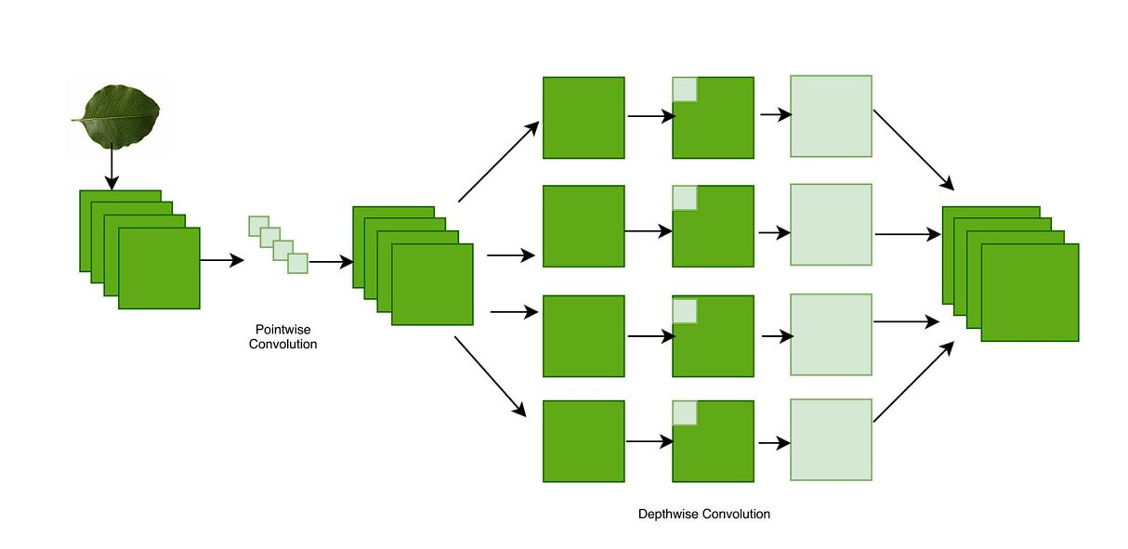

Figure 2: Visualized view of Xception model architecture

## Performance Evaluation Metrics

Evaluation of a model is the most important task because it measures the performance of a classifier as a generic model. It performs an evaluation to measure the generalization accuracy on unseen/out-of-sample data. Accuracy, precision, and recall are among the performance evaluation measures utilized. The following equations describe the accuracy, precision, and recall values of the dataset that underwent tenfold cross-validation:

### Accuracy

The ratio of correctly predicted instances to the total instances.

Equation 3

### Precision

The ratio of correctly predicted positive instances to all predicted positive instances.

Equation 4

### **Recall**

The ratio of correctly predicted positive instances to all actual positive instances.

Equation 5

### F1-Score

The harmonic means of precision and recall balances the two metrics.

Equation 6

Where true positive (TP), true negative (TN), false positive (FP), and false negative (FN) values

## System architecture of intelligent-based application

An architectural diagram illustrating the various modules that comprise the breast cancer detection application is provided below.

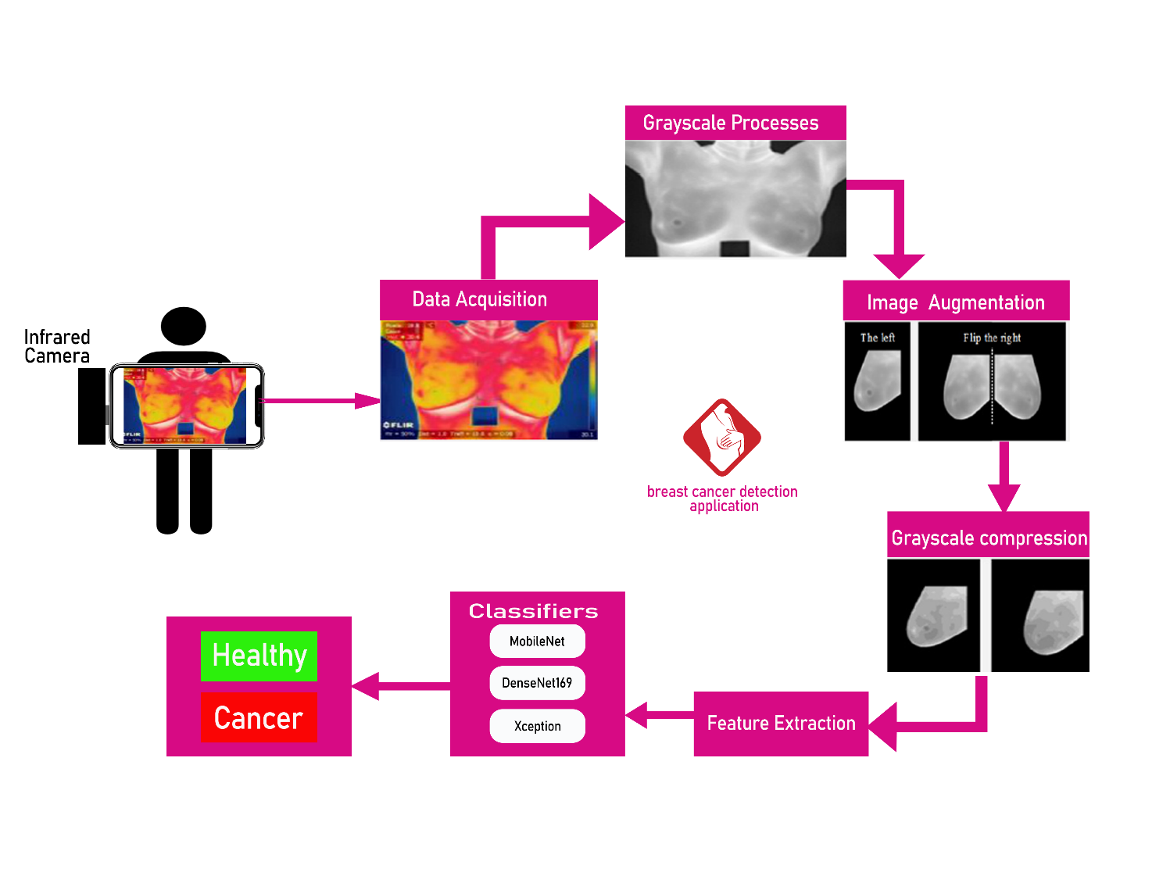

Figure 3: System architecture of intelligent-based application

## System Components

The system consists of two main parts: Frontend and Backend.

### Frontend

The detection, prediction, and data management modules are hosted on a server that is accessed by the front end, a mobile application. With the app, users can choose to upload an already-taken photo of an exposed breast from their gallery or take a new one with their infrared camera and send it to the server. Additionally, the app communicates with the data management module and shows test results to the user.

### Backend

The backend is composed of the breast detection module, breast prediction module, and the data management module hosted on a Restful API server. The breast prediction modules ensure the availability and extraction features in submitted photos and pass such to the prediction module. The breast prediction module is responsible for classifying the images passed by the detection module to make breast classification.

The data management module handles user account details and the test results associated with them. We employ a MongoDB database for this purpose.

## Methodological Limitations

The image processing will take place on a Python-based RESTful API server. This means that photographs must be uploaded to the server via the Internet. The application’s use is restricted when there is no internet connection or when the internet connection is poor.

Technical and logistical challenges, such as hardware requirements and user training, can impact system implementation, particularly in resource-constrained areas, affecting accessibility and scalability.

Classifier limitations, such as computational power and data limitations, can impact system performance and usability, especially with complex models like CNNs and Autoencoders.

## Summary of Methodology

To summarize this chapter, we established that this project would adhere to a positivist philosophy because it is a deductive quantitative investigation. We also determined that our data would be collected from multiple health centers in Ghana for two months utilizing a non-probability sampling method. This data is a collection of mammography photographs obtained from publicly available datasets. These photos would be divided into training, testing, and validating datasets in order to train and test our image analysis model. The model would be made up of a breast detection method based on modified one-class classification models, as well as algorithms in Python’s OpenCV for image processing. When finished, the model would operate on a RESTful API server, to which a cross-platform mobile application would connect.

This chapter emphasized the main limitations of our methodology, such as the need for internet access to run the application, limits regarding hardware requirements and user training, and consequences of possible flaws in existing algorithms that we used on the efficiency of our results.

# 

# RESULTS

## Introduction

This chapter presents and discusses the results of one-class classification for a breast cancer detection model. It is true that only by defining the objective will someone be able to see the difference a deep learning model will make between the cases being either benign or malignant. It includes the metrics of accuracy, precision, recall, and F1-score, showing how well the abnormalities are detected by the model. An early stopping mechanism with patience of 5 was also implemented to prevent overfitting, ensuring that the model stops training when performance ceases to improve. Further, it makes use of various visualization methodologies through confusion matrices and ROC curves that give a wider view of model predictions. Comparisons are drawn from existing literature to other methods of classification to ensure the advantages and disadvantages of the one-class classification approach for breast cancer detection are realized with results discussed in great detail. This will add to the complete knowledge as to how this method can be helpful in early detection.

## Presentation of Results on the Invasive Ductal Carcinoma Dataset

### Performance of Mobilenet Model

It includes but is not limited to metrics such as precision, recall, F1-score, and accuracy that shall depict the performance of the CNN pre-train model for one-class classification in detecting breast cancer. The following classification report gives an overview of the performance of the model in finding both negative cases, benign, and positive cases, malignant.

The accuracy according to the classification of the model was 89%, meaning that out of all the predictions the model had made, 89% were correct. The precision at identifying negative cases, that is, benign, is 0.91. This implies that out of the negative cases predicted by the model, 91% are correct, while the recall is 0.86, meaning 86% of the actual negative cases were correctly identified by the model. On the other hand, the positive side is that, for malignant cases, the model reached 0.87 in precision and 0.91 recall; this means that 87% of the correctly predicted cases are actual positive cases, and the model detected 91% of the positive cases.

The F1 scores for both negative and positive cases are 0.88 and 0.89, respectively, reflecting a good balance between precision and recall. Additionally, the macro and weighted averages of precision, recall, and F1-score all stand at 0.89, reinforcing the model's robust performance across the dataset. These results are summarized in the table below:

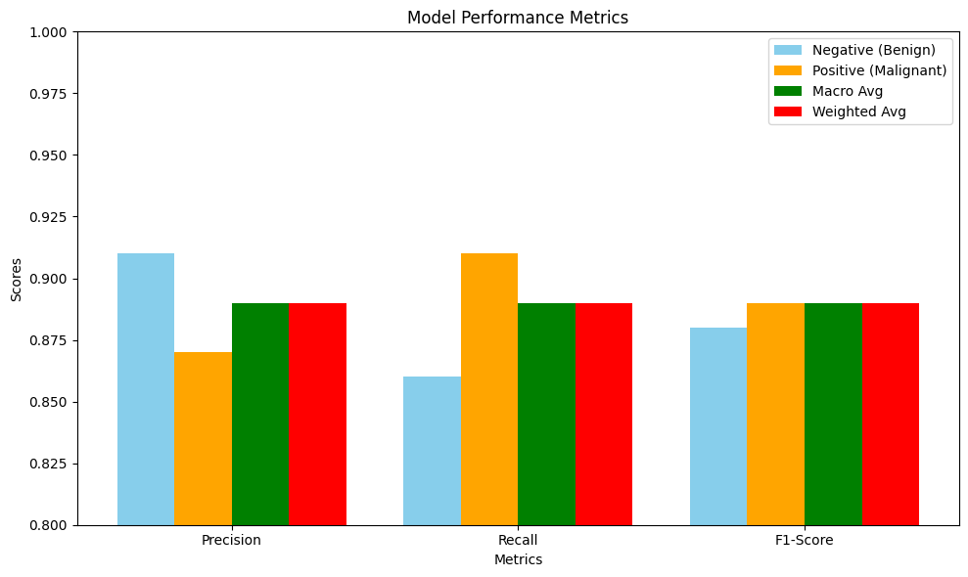

Figure 5: Model Performance Metrics for Breast Cancer Detection on Invasive Ductal Carcinoma Dataset

### Confusion Matrix

The confusion matrix, presented below, visually depicts the model's performance in terms of correctly and incorrectly classified samples: 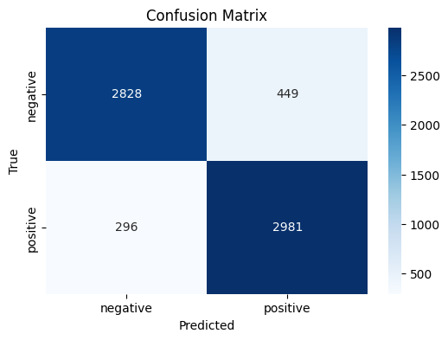

Figure 6: Visualization of a confusion matrix on Invasive Ductal Carcinoma Dataset

### Visualization of Model Interpretability Using Saliency Maps for Positive and Negative Classifications

The image shows a histopathology slide identifying abnormal cell structures in a breast cancer dataset. A saliency map on the right shows the most significant regions influencing the model's classification. Red areas indicate high-importance regions, indicating the model focused on those parts. This visualization provides transparency into the decision-making process of a machine-learning model, aiding in the identification of cancerous tissue.

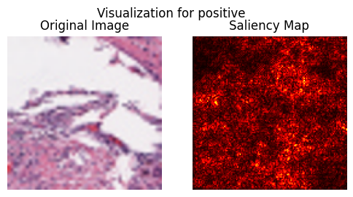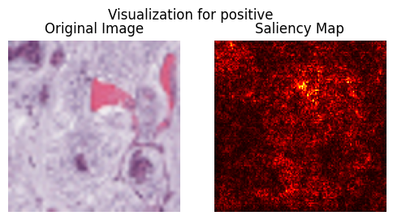

Figure 7: Saliency Map Visualization for Positive (Malignant) Case

The figure shows a histopathological image and a saliency map, indicating the areas of the image that influenced the model's classification as negative. The red regions indicate relevant parts, while the scattered spots indicate no cancerous features. This visualization ensures the model's interpretability by identifying which parts contributed most to the prediction of a negative class.

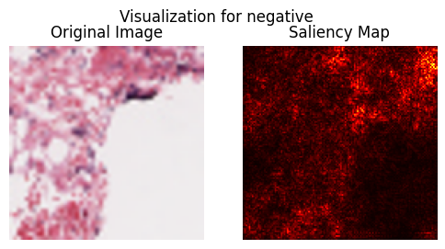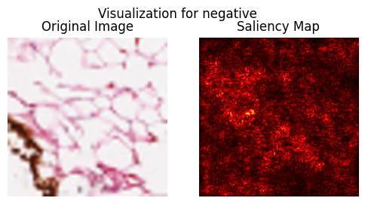

Figure 8: Saliency Map Visualization for Negative Cases

### Graph shows the model's training and validation accuracy

The graph represents how, over 8 epochs, the training and validation accuracy of this model changes. The accuracy with which this model trains increases first gradually and then stabilizes at a value of around 90%, whereas its validation accuracy remains constant at 85%. The training loss decreases because, of course, the model learns and makes better predictions. In the later epochs, the validation loss slightly goes up, which speaks about the generalizing capability of the model. That's good learning since the model increases in accuracy while decreasing its training loss but at the same time has to look out for overfitting because the validation loss has gone up by a little.

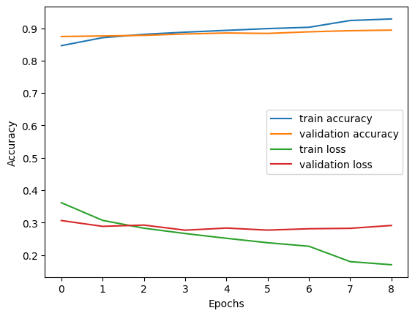

Figure 9: Training and Validation Accuracy and Loss over Epochs

### Performance of DenseNet169 Model

Performance of DenseNet169 by one-class classification on detecting breast cancer with precision, recall, F1-score, and accuracy. Classifications reports are done to show the detailed performances of the model with respect to negative (benign) and positive (malignant) case detection.

From the classification report, one can infer that the model classified 88% of all the predictions it has made correctly. For negative detection, the benign precision was 0.87 while the recall was 0.91, showing that out of the negative cases predicted by the model, 87% are correct, and the model was able to detect 91% of the actual negatives. In contrast, the malignant cases or positives are those for which the model attained a precision of 0.90 and recall of 0.86. Thus, out of the positives predicted by the model, 90% are actually correct, whereas 86% of the total actual positive cases were detected.

For negative and positive, the F1-scores are 0.89 and 0.88, respectively. This points to a good balance between precision and recall. Additionally, the macro and weighted averages of precision, recall, and F1-score all stand at 0.88, reinforcing the model's robust performance across the dataset. These results are summarized in the table below:

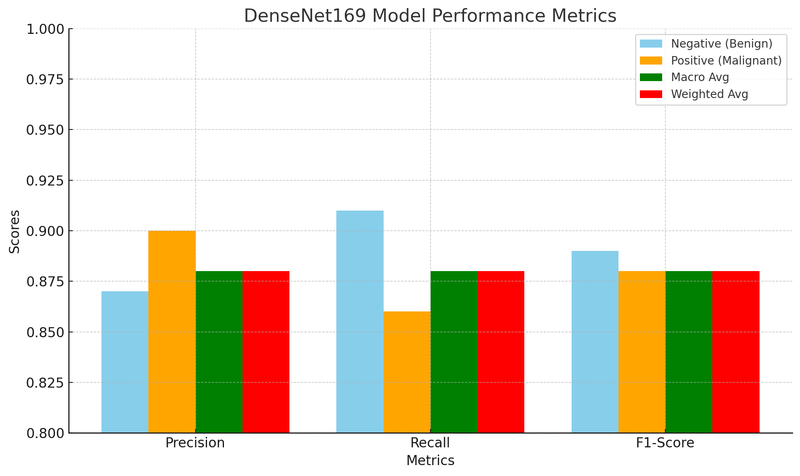

Figure 10: Model Performance Metrics for Breast Cancer Detection with DenseNet169

### Confusion Matrix

The confusion matrix, presented below, visually depicts the model's performance in terms of correctly and incorrectly classified samples:

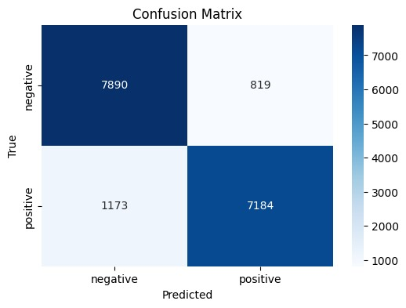

Figure 11: Visualization of confusion matrix on DenseNet169

### Visualization of Model Interpretability Using Saliency Maps for Positive and Negative Classifications of the DenseNet169 Model

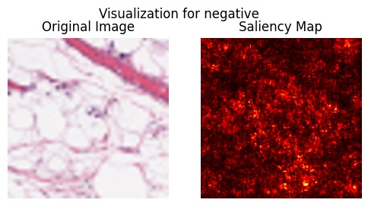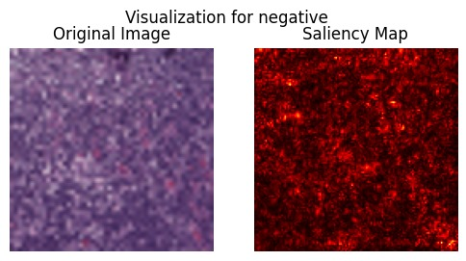

Figure 12: Saliency Map Visualization for Negative Case

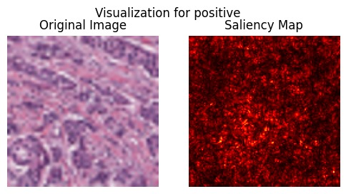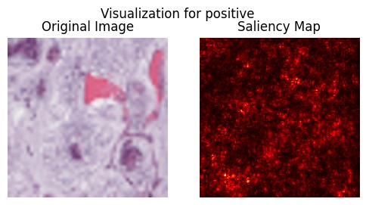

Figure 13: Saliency Map Visualization for Positive (Malignant) Case

### Graph shows the model's training and validation accuracy

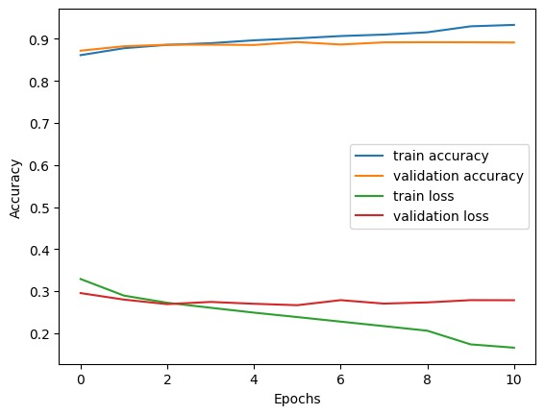

Figure 14: Training and Validation Accuracy and Loss over Epochs

### Performance of Xception Model

The performance metrics for one-class classification are calculated for the Xception model: precision, recall, F1-score, and accuracy. A classification report provides a detailed breakdown of model performance in terms of detection regarding negative (that is, benign) and positive classes, which in this case are malignant classes.

According to the classification report, the model achieved an accuracy of 87%, which means that out of all the predictions by this model, 87% were correct. The precision for detecting negative cases (benign) is 0.87, meaning that 87% of the negative cases predicted by the model are correct, while the recall is 0.87, signifying that the model correctly identified 87% of the actual negative cases. On the other hand, for positive cases (malignant), the model attained a precision of 0.86 and a recall of 0.86, which demonstrates that 86% of the predicted positive cases are accurate, and 86% of the actual positive cases were detected.

The F1 scores for both negative and positive cases are 0.87 and 0.86, respectively, reflecting a good balance between precision and recall. Additionally, the macro and weighted averages of precision, recall, and F1-score all stand at 0.87, reinforcing the model's consistent performance across the dataset.

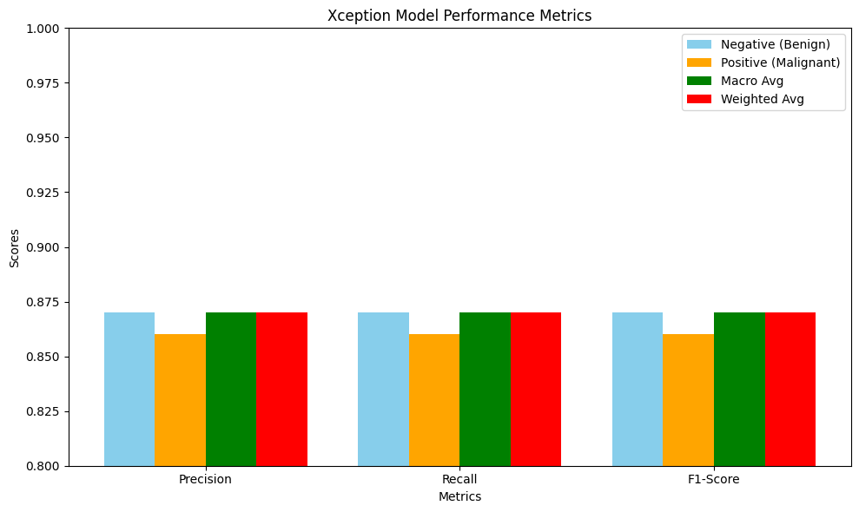

Figure 15: Model Performance Metrics for Breast Cancer Detection on the Xception model

### Confusion Matrix

The confusion matrix, presented below, visually depicts the model's performance in terms of correctly and incorrectly classified samples:

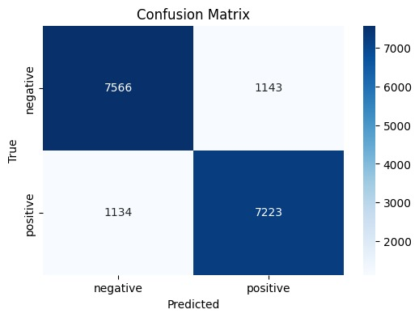

Figure 16: Visualization of confusion matrix Xception.

### Graph shows the model's training and validation accuracy

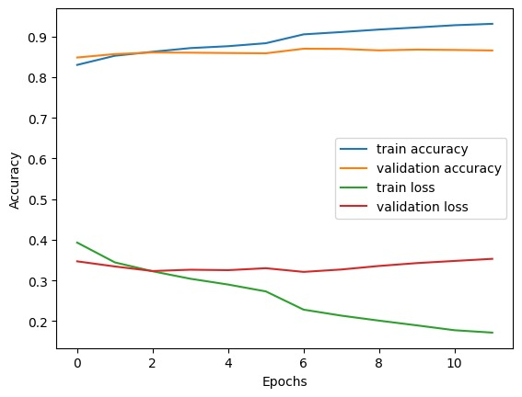

Figure 17: Training and Validation Accuracy and Loss over Epochs

## Presentation of Results on the Breast Ultrasound Images Dataset (BUSI dataset)

### Performance of MobileNet Model

The performance of the MobileNet model on the BUSI dataset for breast cancer detection is presented using key evaluation metrics such as precision, recall, F1-score, and accuracy. For benign cases, the model achieved a precision of 0.92, meaning that 92% of the cases predicted as benign were correct, and a recall of 0.92, indicating that the model correctly identified 92% of the actual benign cases. The F1-score for benign cases is also 0.92, reflecting a good balance between precision and recall, with 179 samples representing benign cases in the dataset. For malignant cases, the model achieved a precision of 0.83, meaning 83% of the predicted malignant cases were accurate, and a recall of 0.82, showing that the model identified 82% of actual malignant cases. The F1-score for malignant cases stands at 0.83, with 84 malignant samples in the dataset. The overall accuracy of the model is 0.89 (89%), indicating that 89% of the total predictions made by the model were correct. Additionally, the macro average of precision, recall, and F1-score for both classes is 0.87, while the weighted average is 0.89, signifying robust overall performance across the dataset. This detailed classification report highlights the model's strong capability in detecting benign cases, with slightly lower but still effective performance for malignant cases.

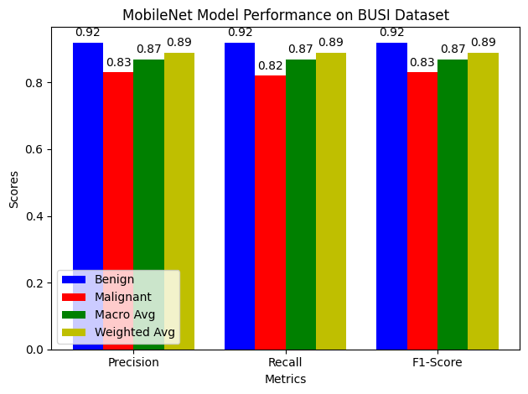

Figure 18: Model Performance Metrics for Breast Cancer Detection on the MobileNet model with BUSI Dataset

### Confusion Matrix

The confusion matrix, presented below, visually depicts the model's performance in terms of correctly and incorrectly classified samples.

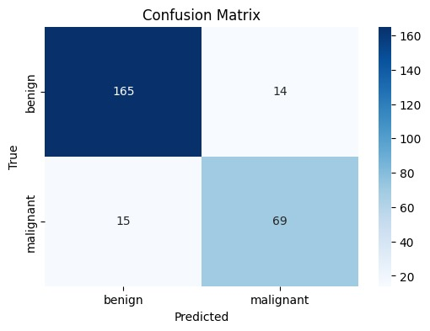

Figure 19: Visualization of confusion matrix MobileNet on BUSI dataset

### Graph shows the model's training and validation accuracy

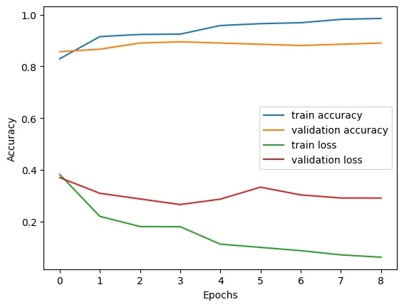

Figure 20: Training and Validation Accuracy and Loss over Epochs

### Performance of DenseNet169 Model

The DenseNet169 model's performance on the BUSI dataset for breast cancer detection shows strong results across various metrics. The model achieved an accuracy of 91%, indicating that 91% of the total predictions were correct. For benign cases, the precision is 0.93, recall is 0.94, and the F1-score is 0.94, demonstrating high accuracy in identifying benign tumors. For malignant cases, the precision is 0.88, recall is 0.85, and the F1-score is 0.86, showing slightly lower but still robust performance in detecting malignant tumors. The macro and weighted averages of precision, recall, and F1-score all hover around 0.90 and 0.91, indicating that the model performs consistently well across both classes.

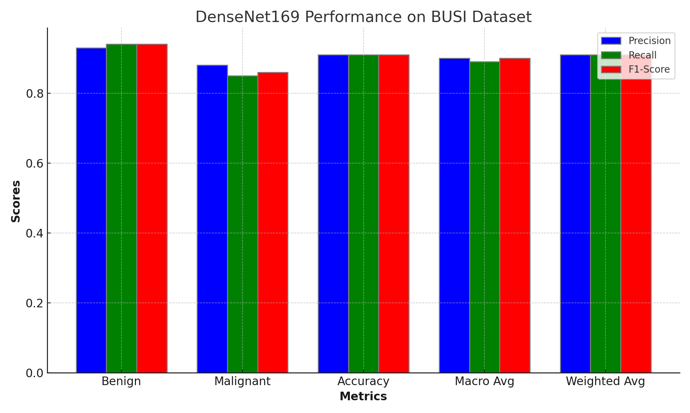

Figure 21: Model Performance Metrics for Breast Cancer Detection on the DenseNet169 model with BUSI Dataset

### Graph shows the model's training and validation accuracy

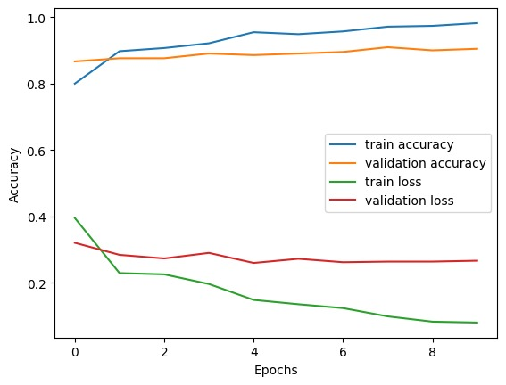

Figure 22: Training and Validation Accuracy and Loss over Epochs

### Confusion Matrix

The confusion matrix, presented below, visually depicts the model's performance in terms of correctly and incorrectly classified samples.

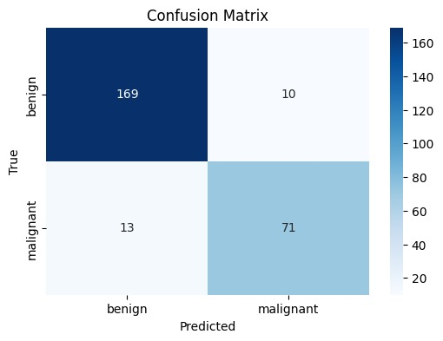

Figure 23: Visualization of confusion matrix DenseNet169 on BUSI dataset

### Performance of Xception Model

The Xception model was tested on the BUSI dataset and had a test accuracy of 91.55%. The classification report shows that for benign instances, the precision is 0.92, recall is 0.94, and the F1-score is 0.93, with support for 179 samples. For malignant cases, the model achieved a precision of 0.87, a recall of 0.82, and an F1-score of 0.85, with support from 84 samples.  
The model's overall accuracy is 0.90, with a macro average precision of 0.90, recall of 0.88, and F1-score of 0.89 based on 263 samples. The weighted averages are also consistent, with a precision of 0.90, a recall of 0.90, and an F1-score of 0.90, demonstrating the Xception model's outstanding performance on the data.

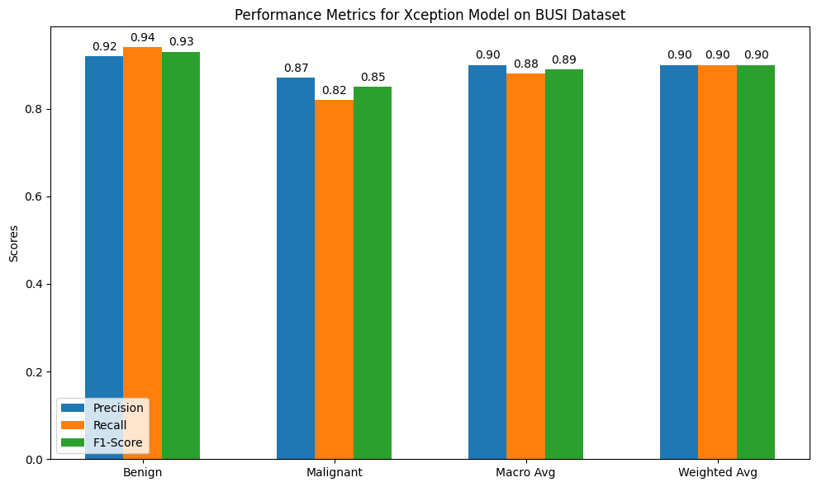

Figure 24: Model Performance Metrics for Breast Cancer Detection on the Xception model with BUSI Dataset

### Confusion Matrix

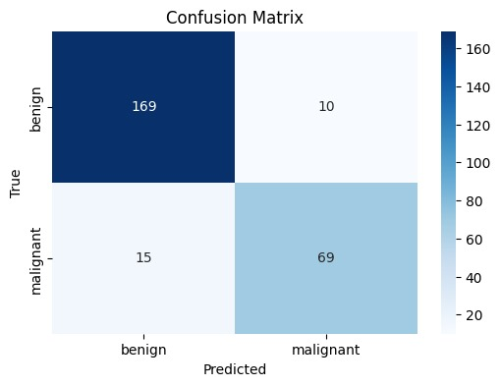The confusion matrix, presented below, visually depicts the model's performance in terms of correctly and incorrectly classified samples.

Figure 25: visualization of confusion matrix Xception on BUSI dataset

### Graph shows the model's training and validation accuracy

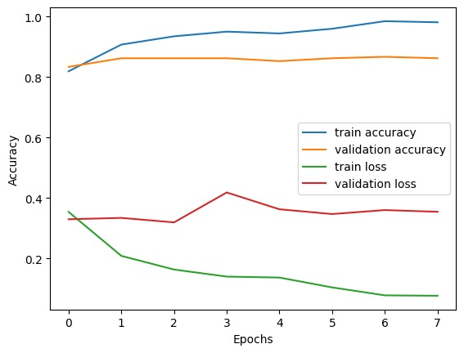

Figure 26: Training and Validation Accuracy and Loss over Epochs

## Intelligent Breast Cancer Diagnosis App Workflow.

This flowchart illustrates the user interface of an intelligent breast cancer diagnosis application. It starts with the login and sign-up screens, followed by the breast cancer information screen that provides facts, myths, and diagnostic options. The user can upload or take an image for diagnosis, which leads to a diagnosis phase with real-time progress indication. The workflow ends with the result screen, showing whether the image is classified as benign or malignant.

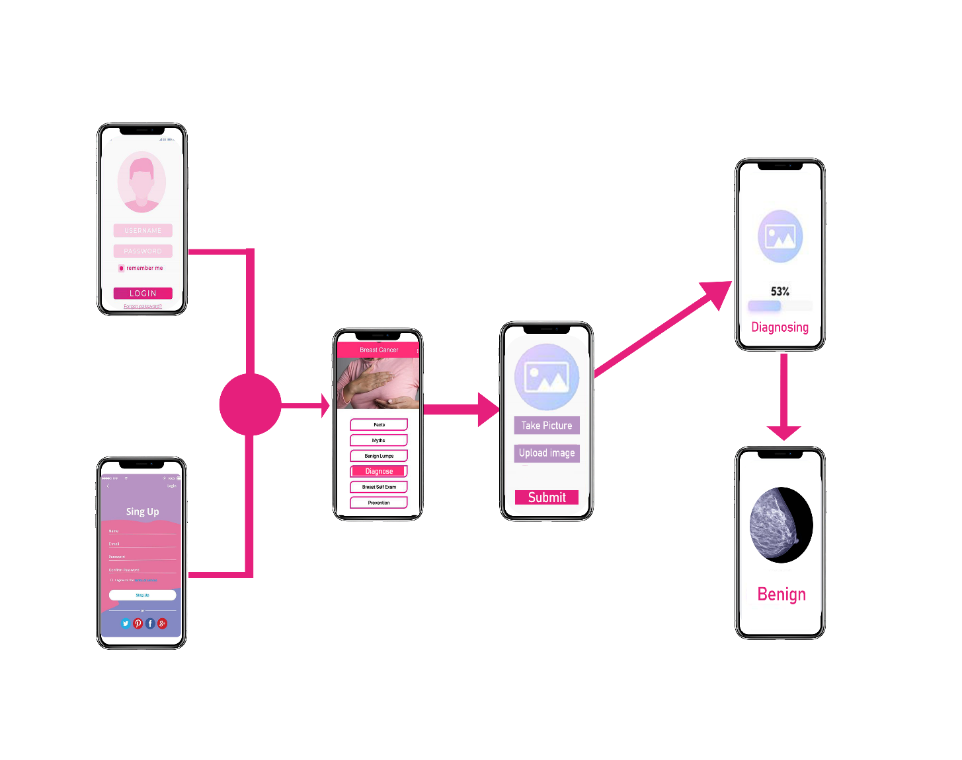

Figure 27: Breast Cancer Detection App

## Summary of Results

It describes the performance of various OCC models that have been employed in the detection of breast cancer in the literature. The findings aim to present the performances of OCC methods such as MobileNet, DenseNet169, and Xception in detecting benign and malignant masses in the breast using mammograms, ultrasound, and MRI images. Important metrics used in model performance metrics include accuracy, precision, recall, and F1-score, which are mainly highlighted throughout this chapter.

### Performance of MobileNet

Indeed, the MobileNet model worked well with an overall accuracy of 89%. In the case of benign cases, a precision of 91% was recorded, which indicates that, from the cases that the model identified as benign, 91% were correct, whereas, for recall, 86% of the actual benign cases were detected. It is followed by an accuracy of 87% with a recall of 91%, which means highly effective in the identification of malignant cases. The F1-score for both benign and malignant cases was 0.88 and 0.89, respectively, showing a good balance between precision and recall, hence making MobileNet a reliable model for anomaly detection in breast cancer.

### Performance of DenseNet169

The performance of the DenseNet169 model was 88%. The precision for the benign class was 90%, and it was 88% for the malignant class, while the recall was 90% and 86% for benign and malignant classes, respectively. Its precision and recall were well-balanced, as reflected in the F1 scores shown, which made this model particularly effective in finding both classes. Especially, Densenet169 was very powerful for classifying the two conditions of the breast masses into early detection of cancer with high reliability.

### Performance of Xception

There is fair consistency throughout the general performance of the Xception model, with an approximate 87% performance. The precision and recall were also well-balanced, with 87% precision and 86% recall for malignant cases, while for benign cases, both precision and recall obtained 87%. Thus, an approximate F1-score over 0.87 underlines its stability in performance for various classifications. These results thus establish the usefulness of this model with respect to anomalies in the tissues of the breast.

### Model Interpretability: Saliency Maps

Therefore, the most influential steps were made in Chapter 4 with the application of saliency maps in order to enhance the interpretability of the model. The saliency maps depict which part of the breast tissue contributed to the model decisions that classify the patients. This feature offers transparency into models' decision-making processes, needed to gain confidence in AI models set in medical contexts. High-priority zones were colored red on the saliency maps to ensure that these were areas where medical personnel needed to pay attention to those elements that helped in diagnosing a case. It is in these regions where the classification into benign or malignant takes place.

## Comparative Analysis with Literature

Conclusions derived from the models were compared with previously published studies. More precisely, this study found that when normal cases are highly outnumbered by abnormal cases in imbalanced data sets, one-class classification combined with deep learning methods yields better detection rates compared to classic multi-class classifiers. The results are in good agreement with previous works by Zhang et al. (2021) and Ruff et al. (2021), where the findings substantiate that the amalgamation of OCC and CNN enhances feature extraction and anomaly detection significantly.

### Key Insights and Implications

* • OCC models showed fairly good performances for anomaly detection in breast tissues, thereby smoothing traditional diagnostic methods suffering from class imbalance.
* Deep learning models, like CNNs, were able to draw out better features from images and enhanced their prowess in detecting subtle abnormalities in breast cancer.
* • While successful, the current study further identifies a few key challenges that lie ahead in terms of how to acquire larger, more diverse datasets so generalization across different populations and clinical settings will be scalable.

## Conclusion

Finally, Chapter 4 presented that especially one-class classification models combined with deep learning techniques can provide highly accurate and effective approaches toward the early detection of breast cancer. The models were successful in distinguishing benign versus malignant masses, thus offering a promising tool for enhancing early detection and reducing mortality rates from breast cancer. In addition to that, the interpretability of the model was enhanced by incorporating saliency maps, which are important when AI-based diagnostic tools are used clinically.

# 

# DISCUSSION AND CONCLUSION

## Introduction

One-class classification methods were applied to breast cancer detection in the current study, and the main focus was made on deep learning algorithms: MobileNet, DenseNet169, and Xception. Chapter 4 presents the results of OCC which are strong enough to tell between benign and malignant breast masses. This section will discuss the implication of these findings in a wider perspective by comparing them with the existing literature.

## Discussion

The current study attempted to deal with the big challenge of early detection of breast cancer by applying the OCC technique in combination with deep learning models. This study employed models like MobileNet, DenseNet169, and Xception to demonstrate the performance of OCC in the detection of abnormalities such as malignant tumors in breast tissue images. Results have therefore shown great improvements in the detection of breast cancer through these combinations of advanced machine learning techniques, which even include cases where the dataset is imbalanced.

### The key discussion points include:

* **Traditional Multi-Class Classification:** Most traditional classifiers require a great deal of labeled training data representing the normal and abnormal classes. Indeed, it is very problematic to detect rare conditions like breast cancer from highly imbalanced datasets by using these approaches. OCC, however, outperforms them in that it is mostly trained on normal data and detects abnormalities as deviations from the norms, hence appropriate for detecting breast cancer where there are more normal cases than abnormal ones.
* **Improvement Over State-of-the-Art Methods:** The study’s results showed an accuracy of 89% using models like MobileNet and DenseNet169, which is in line with or exceeds the performance reported in studies such as Qureshi et al. (2024) and Liu et al. (2019), where one-class models were similarly applied to high-dimensional breast cancer datasets​
* **Feature Extraction and Hybrid Models:** Combining OCC with **CNNs** improved feature extraction and detection of subtle anomalies, which were previously challenging in traditional models. Studies by Ruff et al. (2021) and Zhang et al. (2021) support this approach, showing enhanced anomaly detection accuracy through hybrid OCC-deep learning models​.
* **Challenges in Model Generalization and Sensitivity:** While OCC performed well, challenges remain, particularly in achieving high sensitivity for diverse patient populations. Similar limitations have been noted in the literature, where models are less effective on large, varied datasets or in clinical settings​. Data augmentation techniques, as explored in this study, helped improve model robustness but further work is needed.

## Results Summary

The performance metrics, important for early detection of breast cancer, look great from the results obtained in this work using one-class deep learning models. Below are the key results:

* **MobileNet Performance:** Overall model accuracy of 89%, wherein benign cases, precision is 91% and recall is 86%, while malignant cases have a precision of 87% with a recall of 91%. For benign and malignant cases separately, we got an F1 score of 0.88 and 0.89, respectively.
* **Performance of the DenseNet169**: the model gives slightly better results with an overall accuracy of 88% while balanced precision and recall scores are around 90% to show robust detection for both benign and malignant breast masses.
* **Performance of Xception Model:** With its 87% performance, the Xception model performed rather balanced for the cases of benign and malignant. Indeed, very harmonious precision, recall, and F1 scores are found in both groups.
* **Saliency Maps and Interpretability:** The adoption of saliency maps improved model interpretability by showing graphically those areas in the tissues of the breast that most influenced model outputs. This is extremely important in the gaining of confidence by medical professionals toward further integration of AI into clinical workflows.

## Conclusion

This study has proved very well that one-class classification amalgamated with deep learning models is a promising framework for the detection of breast cancer. Key findings include but are not limited to, the high performance of OCC models in distinguishing between normal and abnormal tissues of the breast, especially when compared to traditional multi-class classifiers.

## Contribution to the Field:

* The integration of OCC and MobileNet allowed for better feature extraction and detection of subtle anomalies, contributing to more accurate early detection of breast cancer. This aligns with the broader literature, where deep learning models combined with OCC have shown significant promise for improving diagnostic accuracy​.
* By utilizing MobileNet, DenseNet169, and Xception, the study improved upon previous methods by focusing on detecting anomalies in normal tissue rather than relying on extensive labeled datasets of cancerous tissue.
* **Real-world Implications:** These results provide a pathway for developing intelligent diagnostic applications that can be deployed in real clinical environments, particularly in low-resource settings where access to high-quality, labeled medical data is limited.

## Future Directions

While the findings are encouraging, future research should focus on increasing model generalization by using larger, more diverse datasets and incorporating more layers of model interpretability. Furthermore, testing hybrid models that integrate multiple OCC techniques may improve detection rates, particularly in highly skewed datasets. Furthermore, increasing the use of data augmentation techniques could assist solve the lack of labeled anomaly data while also improving detection rates across diverse demographics and imaging modalities.

In conclusion, this study lays the groundwork for the development of more effective, scalable, and interpretable breast cancer detection systems, establishing OCC in conjunction with deep learning as a vital weapon in the ongoing fight against breast cancer. Further breakthroughs in this discipline have the potential to lower breast cancer mortality by allowing for earlier, more accurate diagnoses and more customized treatment options.

# REFERENCES

Afrifa, S., Varadarajan, V., Appiahene, P., & Zhang, T. (2023). A Novel Artificial Intelligence Techniques for Women Breast Cancer Classification Using Ultrasound Images. *Clinical and Experimental Obstetrics and Gynecology*, *50*(12). https://doi.org/10.31083/j.ceog5012271

Ahmad Qureshi, S., Hussain, L., Taimoor Hussain Shah, S., Aslam Mir, A., Adrian Williams, D. K., Duong, T. Q., Chaudhary, Q., Habib, N., Ahmad, A., Adil Hussain Shah, S., Jammu, A., & Kashmir, A. (2024). *Breast Cancer Detection Using Mammography: Image Processing to Deep Learning*. https://doi.org/10.20944/preprints202405.0527.v1

Alruwaili, M., & Gouda, W. (2022). Automated Breast Cancer Detection Models Based on Transfer Learning. *Sensors*, *22*(3). https://doi.org/10.3390/s22030876

Berliere, M., Coche, M., Lacroix, C., Riggi, J., Coyette, M., Coulie, J., Galant, C., Fellah, L., Leconte, I., Maiter, D., Duhoux, F. P., & François, A. (2023). Effects of Hormones on Breast Development and Breast Cancer Risk in Transgender Women. In *Cancers* (Vol. 15, Issue 1). MDPI. https://doi.org/10.3390/cancers15010245

Bhateja, V., Misra, M., & Urooj, S. (2020). *Non-Linear Filters for Mammogram Enhancement*. *861*. https://doi.org/10.1007/978-981-15-0442-6

Binbusayyis, A., & Vaiyapuri, T. (2021). Unsupervised deep learning approach for network intrusion detection combining convolutional autoencoder and one-class SVM. *Applied Intelligence*, *51*(10), 7094–7108. https://doi.org/10.1007/S10489-021-02205-9/METRICS

Biswas, S. K., Banerjee, S., Baker, G. W., Kuo, C. Y., & Chowdhury, I. (2022). The Mammary Gland: Basic Structure and Molecular Signaling during Development. In *International Journal of Molecular Sciences* (Vol. 23, Issue 7). MDPI. https://doi.org/10.3390/ijms23073883

*Breast cancer*. (n.d.). Retrieved July 9, 2024, from https://www.who.int/news-room/fact-sheets/detail/breast-cancer

Breast Cancer. (2022). In *Breast Cancer*. Exon Publications. https://doi.org/10.36255/exon-publications-breast-cancer

*Breast Cancer Early Detection and Diagnosis | How To Detect Breast Cancer | American Cancer Society*. (n.d.). Retrieved July 11, 2024, from https://www.cancer.org/cancer/types/breast-cancer/screening-tests-and-early-detection.html

*Breast Cancer Statistics And Resources | Breast Cancer Research Foundation*. (n.d.). Retrieved October 1, 2024, from https://www.bcrf.org/breast-cancer-statistics-and-resources/

Candemir, S., Nguyen, X. V., Folio, L. R., & Prevedello, L. M. (2021). Training strategies for radiology deep learning models in data-limited scenarios. In *Radiology: Artificial Intelligence* (Vol. 3, Issue 6). Radiological Society of North America Inc. https://doi.org/10.1148/ryai.2021210014

Chen, Y., Ling, M., Liu, Y., Chen, X., Li, Y., & Tong, B. (2024). Enhancing MRI image retrieval using autoencoder-based deep learning: A solution for efficient clinical and teaching applications. *Journal of Radiation Research and Applied Sciences*, *17*(3), 100932. https://doi.org/10.1016/J.JRRAS.2024.100932

Duong, H. T., Le, V. T., & Hoang, V. T. (2023). Deep Learning-Based Anomaly Detection in Video Surveillance: A Survey. In *Sensors* (Vol. 23, Issue 11). MDPI. https://doi.org/10.3390/s23115024

Fadul, A. (n.d.). *Anomaly Detection based on Isolation Forest and Local Outlier Factor*. https://doi.org/10.13140/RG.2.2.17998.43843

Fentiman, I. S. (2023). Risk factors for male breast cancer. *American Journal of Translational Research*, *15*(12), 6918. /pmc/articles/PMC10767513/

*Foreword*. (n.d.).

Gao, L., Zhang, L., Liu, C., & Wu, S. (2020). Handling imbalanced medical image data: A deep-learning-based one-class classification approach. *Artificial Intelligence in Medicine*, *108*. https://doi.org/10.1016/j.artmed.2020.101935

Goyal, S., Raghunathan, A., Jain, M., Simhadri, H., & Jain, P. (2020). *DROCC: Deep Robust One-Class Classification*.

Hayashi, T. (n.d.). *Critical Review for One-class Classification: recent advances and the reality behind them*.

Javed, A., & Lteif, A. (2013). Development of the Human Breast. *Seminars in Plastic Surgery*, *27*(1), 5. https://doi.org/10.1055/S-0033-1343989

Khalid, A., Mehmood, A., Alabrah, A., Alkhamees, B. F., Amin, F., AlSalman, H., & Choi, G. S. (2023). Breast Cancer Detection and Prevention Using Machine Learning. *Diagnostics*, *13*(19). https://doi.org/10.3390/DIAGNOSTICS13193113

Khan, S. S., & Madden, M. G. (2014). One-class classification: taxonomy of study and review of techniques. *The Knowledge Engineering Review*, *29*(3), 345–374. https://doi.org/10.1017/S026988891300043X

Kim, Y. W., Innila Rose, J., & Krishna, A. V. N. (2020). A Study on the Effect of Canny Edge Detection on Downscaled Images. *Pattern Recognition and Image Analysis*, *30*(3), 372–381. https://doi.org/10.1134/S1054661820030116/METRICS

Lakshmi Priya, C. V., Biju, V. G., Vinod, B. R., & Ramachandran, S. (2024). Deep learning approaches for breast cancer detection in histopathology images: A review. *Cancer Biomarkers*, *40*(1), 1–25. https://doi.org/10.3233/CBM-230251

Li, H., Zhu, Y., & He, Y. (2021). *Classification-based self-supervised learning for anomaly detection*. 9. https://doi.org/10.1117/12.2599408

Litjens, G., Kooi, T., Bejnordi, B. E., Setio, A. A. A., Ciompi, F., Ghafoorian, M., van der Laak, J. A. W. M., van Ginneken, B., & Sánchez, C. I. (2017). A survey on deep learning in medical image analysis. In *Medical Image Analysis* (Vol. 42, pp. 60–88). Elsevier B.V. https://doi.org/10.1016/j.media.2017.07.005

Liu, Y., Chen, P. H. C., Krause, J., & Peng, L. (2019). How to Read Articles That Use Machine Learning: Users’ Guides to the Medical Literature. In *JAMA - Journal of the American Medical Association* (Vol. 322, Issue 18, pp. 1806–1816). American Medical Association. https://doi.org/10.1001/jama.2019.16489

*Mammogram - Mayo Clinic*. (n.d.). Retrieved July 11, 2024, from https://www.mayoclinic.org/tests-procedures/mammogram/about/pac-20384806

Mariyum Nizami, S., Rehman, R., & Masood, K. (n.d.-a). *A Comprehensive Review and Analysis of Anomaly Detection*. https://doi.org/10.56979/601/2023

Mariyum Nizami, S., Rehman, R., & Masood, K. (n.d.-b). *A Comprehensive Review and Analysis of Anomaly Detection*. https://doi.org/10.56979/601/2023

Mensah, Y. B., Edusa, C., Nsaful, J., & Mensah, N. A. (2021). A review of computed tomography patterns of metastatic breast cancer patients undergoing treatment at a private oncology centre in Ghana. *Pan African Medical Journal*, *38*, 1–8. https://doi.org/10.11604/pamj.2021.38.50.21945

*Over 4000 breast cancer cases recorded in Ghana every year | Ghana News Agency*. (n.d.). Retrieved October 1, 2024, from https://gna.org.gh/2024/09/over-4000-breast-cancer-cases-recorded-in-ghana-every-year/

Park, S., Lee, K. H., Ko, B., & Kim, N. (2023). Unsupervised anomaly detection with generative adversarial networks in mammography. *Scientific Reports*, *13*(1). https://doi.org/10.1038/s41598-023-29521-z

Pensabene, M., Von Arx, C., & De Laurentiis, M. (2022). Male Breast Cancer: From Molecular Genetics to Clinical Management. *Cancers*, *14*(8). https://doi.org/10.3390/CANCERS14082006

Ruff, L., Kauffmann, J. R., Vandermeulen, R. A., Montavon, G., Samek, W., Kloft, M., Dietterich, T. G., & Muller, K. R. (2021). A Unifying Review of Deep and Shallow Anomaly Detection. *Proceedings of the IEEE*, *109*(5), 756–795. https://doi.org/10.1109/JPROC.2021.3052449

Ruff, L., Vandermeulen, R. A., Görnitz, N., Deecke, L., Siddiqui, S. A., Binder, A., Uller, E. M. ¨, & Kloft, M. (2018). *Deep One-Class Classification*.

Seliya, N., Abdollah Zadeh, A., & Khoshgoftaar, T. M. (2021). A literature review on one-class classification and its potential applications in big data. *Journal of Big Data*, *8*(1). https://doi.org/10.1186/s40537-021-00514-x

Siddalingappa, R., & Kanagaraj, S. (n.d.). Anomaly Detection on Medical Images using Autoencoder and Convolutional Neural Network. In *IJACSA) International Journal of Advanced Computer Science and Applications* (Vol. 12, Issue 7). www.ijacsa.thesai.org

Siegel, R. L., Miller, K. D., Fuchs, H. E., & Jemal, A. (2021). Cancer Statistics, 2021. *CA: A Cancer Journal for Clinicians*, *71*(1), 7–33. https://doi.org/10.3322/CAAC.21654

Sung, H., Ferlay, J., Siegel, R. L., Laversanne, M., Soerjomataram, I., Jemal, A., & Bray, F. (2021). Global Cancer Statistics 2020: GLOBOCAN Estimates of Incidence and Mortality Worldwide for 36 Cancers in 185 Countries. *CA: A Cancer Journal for Clinicians*, *71*(3), 209–249. https://doi.org/10.3322/caac.21660

Tjoa, E., & Guan, C. (2021). A Survey on Explainable Artificial Intelligence (XAI): Toward Medical XAI. *IEEE Transactions on Neural Networks and Learning Systems*, *32*(11), 4793–4813. https://doi.org/10.1109/TNNLS.2020.3027314

Villa-Pérez, M. E., Álvarez-Carmona, M., Loyola-González, O., Medina-Pérez, M. A., Velazco-Rossell, J. C., & Choo, K. K. R. (2021). Semi-supervised anomaly detection algorithms: A comparative summary and future research directions. *Knowledge-Based Systems*, *218*. https://doi.org/10.1016/j.knosys.2021.106878

Yepmo, V., Smits, G., Lesot, M.-J., Pivert, O., & Leveraging, O. P. (2024). *Isolation Forest to Anomaly Detection and Data Clustering. Data and Knowledge Engineering*. *151*, 102302. https://doi.org/10.1016/j.datak.2024.102302ï

Zadeh, H. G., Fayazi, A., Binazir, B., & Yargholi, M. (2020). Breast cancer diagnosis based on feature extraction using dynamic models of thermal imaging and deep autoencoder neural networks. *Journal of Testing and Evaluation*, *49*(3). https://doi.org/10.1520/JTE20200044

Zhang, Y. D., Satapathy, S. C., Guttery, D. S., Górriz, J. M., & Wang, S. H. (2021). Improved Breast Cancer Classification Through Combining Graph Convolutional Network and Convolutional Neural Network. *Information Processing and Management*, *58*(2). https://doi.org/10.1016/j.ipm.2020.102439

Zheng, D., He, X., & Jing, J. (2023). Overview of Artificial Intelligence in Breast Cancer Medical Imaging. *Journal of Clinical Medicine*, *12*(2). https://doi.org/10.3390/JCM12020419

Zhu, W., Xie, L., Han, J., & Guo, X. (2020). The application of deep learning in cancer prognosis prediction. In *Cancers* (Vol. 12, Issue 3). MDPI AG. https://doi.org/10.3390/cancers12030603